ULTRACAM

Opto-mechanical chassis design

Version 1. May 16 2001

The opto-mechanical chassis houses all of the optical assemblies, which include the collimator, three re-imaging cameras with associated filters and two dichroic beam splitters as well as three CCD camera heads and an SDSU controller. A double octopod design was chosen for easy internal access to the instrument whilst providing a relatively lightweight, low flexure chassis. A sub-structure houses the dichroic beam splitters and re-imaging cameras and is itself mounted to the double octopod along with the CCD camera heads and SDSU controller.

- Double Octopod Structure

  - General requirements

The double octopod structure is required to have the following functionality:

- Accommodate any orientation
- Support the sub-structure, CCD camera heads and SDSU controller
- Allow easy access to adjustable components in the instrument
- Low flexure (less than 13 micron)
- Light weight (total instrument weight less than 100kg)
- Allow three axis adjustment of CCD camera heads.
- Low thermal expansion
- Compact (must mount onto the Aristarchos Telescope)
- Must be able to mount on several different telescopes

The structure in figure 1 is both rigid and lightweight. As the orientation of the instrument changes the struts, in a serrurier truss design, equally share the load. Ultracam is designed to fit the Aristarchos telescope, since this is where it will spend most of its life. Because this space envelope on Aristarchos is small, ultracam should have few problems mounting to other 2-m class and larger telescopes.

The maximum length the instrument can be is 850-mm. This is the distance from the telescope focal plane on the side port to the telescope fork. Given that the width of ultracam is finite this length is much shorter since the instrument will be rotating due to the de-rotator of the telescope.

The length of the design is 578.40-mm. However ultracam has to mount 35.40-mm away from the telescope focal plane giving a total instrument length of 613.80-mm. The arc this produces as it rotates is well with in the space envelope. A mounting collar will have to be manufactured to bridge the distance between ultracam and the mounting port of the telescope. This will have to be done for each telescope that ultracam visits.
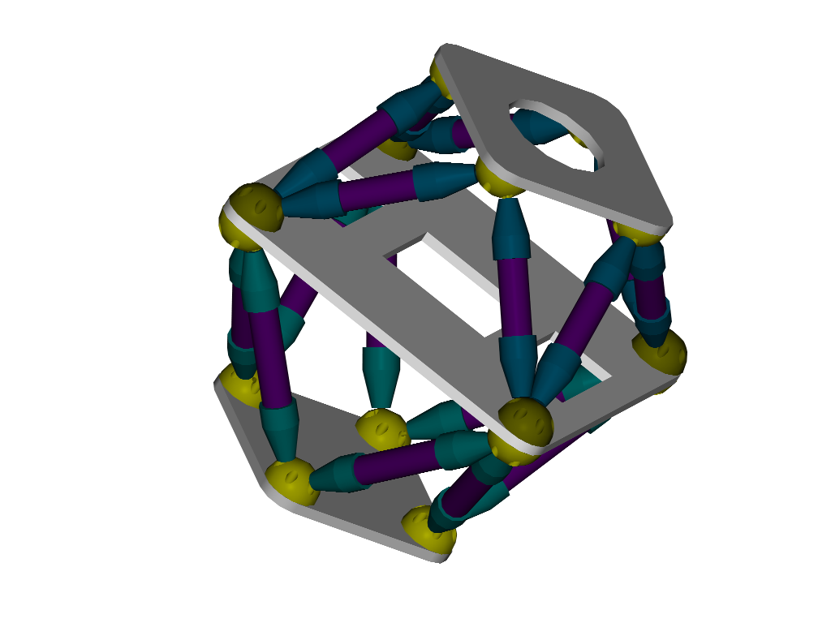
Figure 1. Double octopod chassis.

  - Chassis components

    - Hemispherical joints

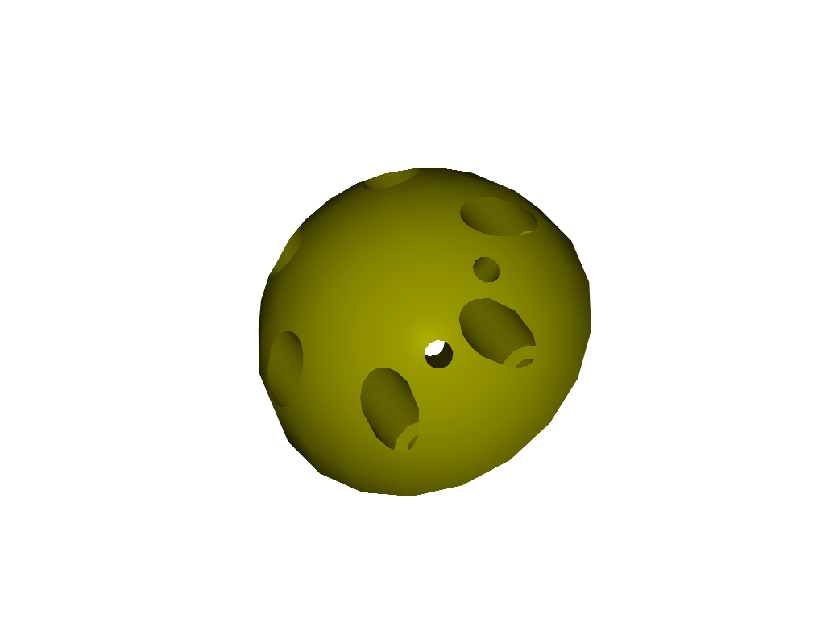
The chassis consists of 16 struts securing three parallel plates by hemispherical joints. The hemispheres are 80-mm diameter machined aluminium and each is fixed by six M6 socket head bolts to it respective plate. The middle plate hemispheres bolt through the plate and locate with threaded holes on the opposing hemisphere.
Figure 2. Hemispherical joint.

The struts connect to the hemispheres by an M8 stainless steel socket head bolt at an angle, which maintains the required separation of the top and bottom plates, 242-mm and 291-mm respectively. The angle of the threaded holes for the upper half of ultracam is 45 degrees from the plate surface and 50 degrees for the lower half of the instrument. The angle is measured in the plane of the hole.

    - Struts

The struts are composed of two strut-ends and a cylinder, the ends of which are oppositely threaded. The strut ends form a hollow cone of wall thickness 5-mm. At the end of the cone is an M8 hole to allow fixing to the hemispheres. A T-shaped slot will be machined into the side of the cone to allow a hexagon key access to tighten the M8 socket head bolts.
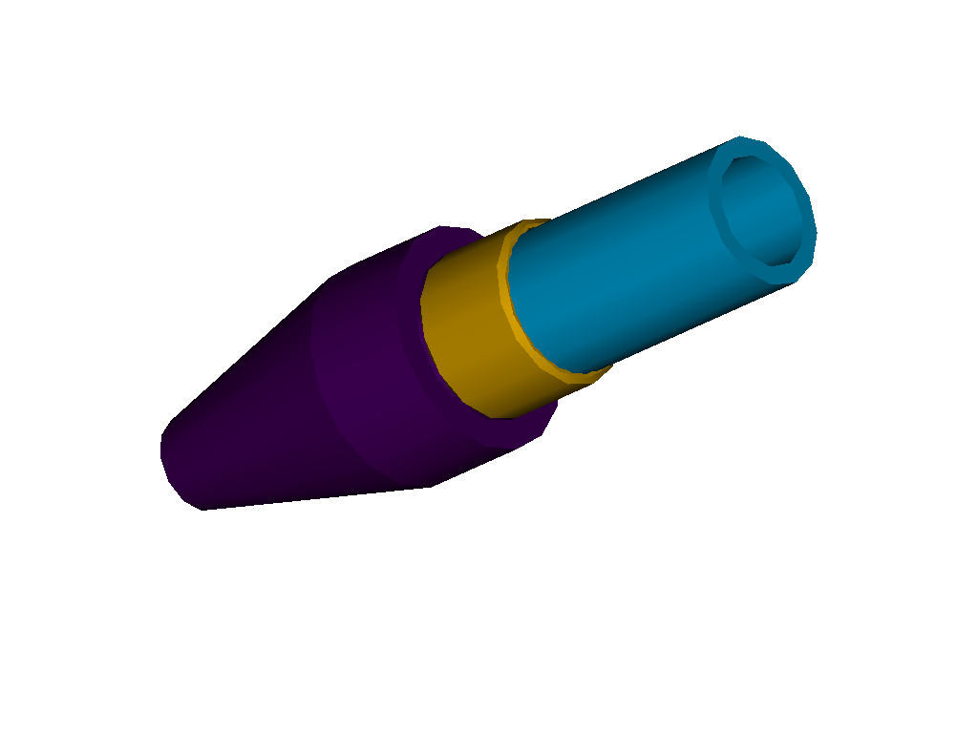
Figure 3. Threaded strut.

The threaded struts will allow limited but fine adjustment in the plate separation in order to make the plates parallel. Figure 3 shows half of a strut assembly. The strut ends will be aluminium and the tubes will be carbon fibre to reduce weight and the effects of thermal expansion. Threading will be added to carbon fibre tubes by a threaded stainless steel collar, which will either be glued to the tube or pinned. The struts also offer the added bonus of being used to duct wiring or plumbing for the various components of the instrument.

1.2.3 Plates

The plates are all 15-mm thick aluminium. The middle plate is 540-mm square with cut-away sections to accommodate the CCD heads and sub-structure. Through holes are drilled in each corner for the hemispheres. The plate corners are filleted to radius 40-mm, the same radius as the hemispheres. The SDSU controller will mount onto the middle plate and will extend out of the confines of the octopod structure. The controller will be thermally and electrically isolated from the structure by a layer of G10.

The top plate is 300-mm square with a disc cut-away to allow the collimator to pass through. The hole is large enough for the WHT collimator of diameter 146-mm. The top plate also acts as the telescope mounting plate. The chassis is designed so that the top plate is level with the top of the Aristarchos collimator barrel. A mounting collar will be necessary for each telescope ultracam visits to achieve the required distance of the collimator from the telescope focal plane. The collar could be a truss design or solid depending on the weight restrictions of the telescope.

1.2.4 CCD head mounting

The mounting of the CCD heads is complicated by the fact that the u’ and g’ band CCDs have to be recessed into the middle plate and mounted in aluminium cradles. The r’ band CCD head is simply mounted so that it points upwards towards its re-imaging camera. Each are secured to the structure by an L-shaped bracket fitted to the CCD head lid. The bracket is designed to fit around the filter holders to save space in the optical axis plane. Each unit is electrically and thermally isolated from the structure by a layer of G10 on the mounting surface.

The recess for the u’ and g’ band CCDs allows 5-mm either side of the long axis of the heads for position adjustments. The CCD heads are sunk 31-mm into the middle plate, which leaves adequate space for the wiring connections in the sides of the box.

The CCDs are required to move along the beam axis to accommodate filter thickness of 5 – 10-mm. The different optical depths of different filter thickness will cause the focal point to change. A single axis translation stage with a travel range of 25-mm will provide the necessary motion to accommodate the different filter thickness. Such products are readily available from optics suppliers. The UMR8.4/8.25 supplied by Newport has been chosen for its compact size, range of travel and high load capacity in x and z planes. The CCD head and translation stage will be mounted on three pads so that tip and tilt adjustments can be made using shimming stock. Slotted bolt holes will provide rough position adjustments.
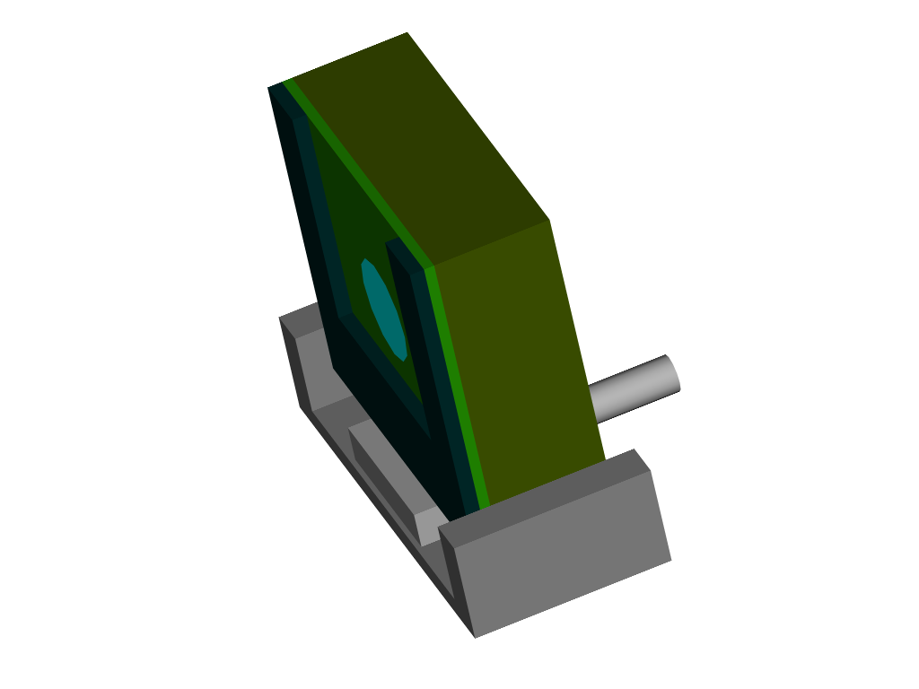
Figure 4. CCD head mounted on a translation stage and cradle
1.3 Weight

From Mechanical desktop drawings the weight of the whole instrument including the sub-structure and all optical components is approximately 75 kg. This is below 100kg the limit suggested the Aristarchos group.

1.4 Flexure

The strut tubing is 40-mm diameter with 5-mm wall thickness. The deflection of lower plate with respect to the upper plate in the horizontal position using this dimension tubing has been calculated to be approximately 5 microns assuming rigid joints. The flexure was calculated using the following formula:
$Δ=\frac{{\text{WL}}^{3}}{c^{2}\text{AE}}$
Equation 1

Where, Δ= flexure
W = Total loading force on trusses
L = Length of truss tube (342-mm upper half, 379-mm lower half)
c = Base length of the triangle formed by the struts
A = Cross sectional area of tube
E = Modulus of elasticity

The flexure was calculated in two parts. The first calculation was for the upper half of ultracam with load of the entire system acting at middle plate. The second calculation determined the flexure for the lower half of the instrument with the load of that half acting on the bottom plate. The total flexure is sum of these two values.

Minimal flexure is especially important in ultracam, as the three CCD heads have to be aligned pixel-to-pixel. The pixel size is 13 microns so the calculated flexure should not present any serious problems.

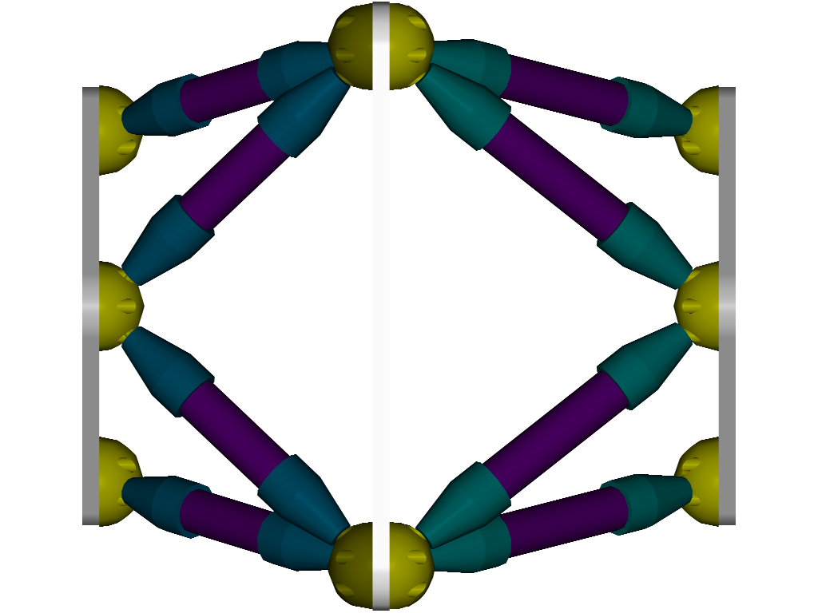

Top Bottom Plate Plate

Figure 5. Flexure analysis

2. The sub-structure

2.1 General requirements

The sub-structure should have the following functionality:

- Accommodate any orientation
- Support the three re-imaging cameras, collimator and dichroic beam splitters
- Be supported on the double octopod structure
- Be sealed to protect optics from dust and environmental factors
- Allow access to the dichroic beam splitters for adjustment

Figure 6 shows the sub-structure with the three re-imaging cameras and collimator fitted. The dichroic beam splitters are housed inside the sub-structure hull, which provides a sealed unit. The whole thing then fixes to the middle plate of the double octopod by a series of brackets. This is the only point where the structure contacts the main chassis. That way the alignment of the optics is determined only by their individual mounting onto the sub-structure.
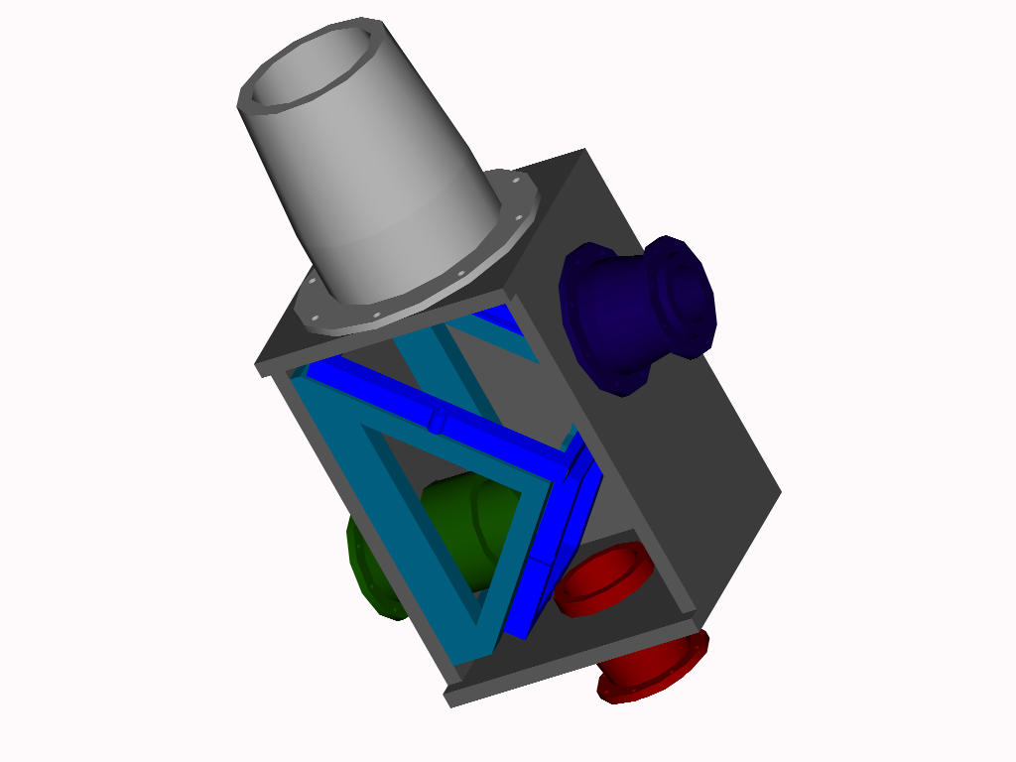
Figure 6. Sub-structure

2.2 Dichroic mounts

The dichroics will be mounted into a frame to make them easier to handle and minimise surface distortions due to mounting. When in its frame the substrate can be positioned laterally by grub screws in the frame edges. The frame is then mounted by three pads allowing tip and tilt adjustment using shimming stock. The three mounting points will be M5 slotted holes to provide preliminary alignment. In each frame mount, complications occur gaining access to one of the three mounting points. This may be resolved by making the sub-structure hull longer. Figure 7 shows a dichroic frame with three mounting points. Each substrate has at least a 5-mm border on which to mount
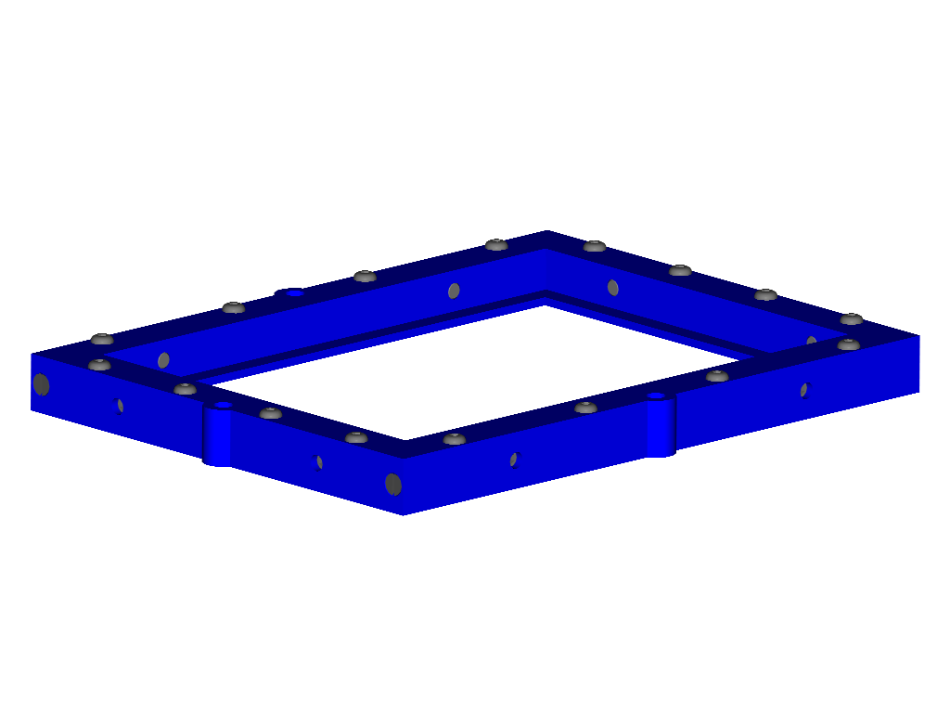
Figure 7. Dichroic mounting frame

The dichroic frames mount onto an aluminium block, which separates them by 105-mm, the distance from the first surface of the first dichroic to the second surface of the second dichroic. Separation of the two can be adjusted by small increments using shim stock at each of the three frame mount points. The dichroic mounting block is bolted to the sub-structure hull. The hull is aluminium sheet, 10-mm thick that bolts together to form a sealed box. Access to adjust the dichroic frames is provided by removable panels in the substructure hull.

2.3 Re-imaging camera and collimator mounts

The three cameras bolt directly to the sub-structure hull by a circular flange coupling with eight M4 bolts. Shim stock at four of the holes will provide means of adjusting the re-imaging cameras to align them. The collimators are mounted in a similar way using eight M6 bolts. Oversized bolt holes in each case should provide enough x,y adjustment to align with the optical axis.

2.4 Filter mounts

The filters mount directly onto the re-imaging camera barrels by a circular flange. The unit comprises of a holder and a cartridge into which the filters are pre-loaded. The cartridge can accommodate up to 50-mm square filters of 10-mm thickness. Filters smaller in size than this will require packing material to mount them into the cartridge. The filter holder and cartridge protrude 12-mm from the end of the camera barrel. The edge of the camera barrel from the last optical element is on average 2-mm.
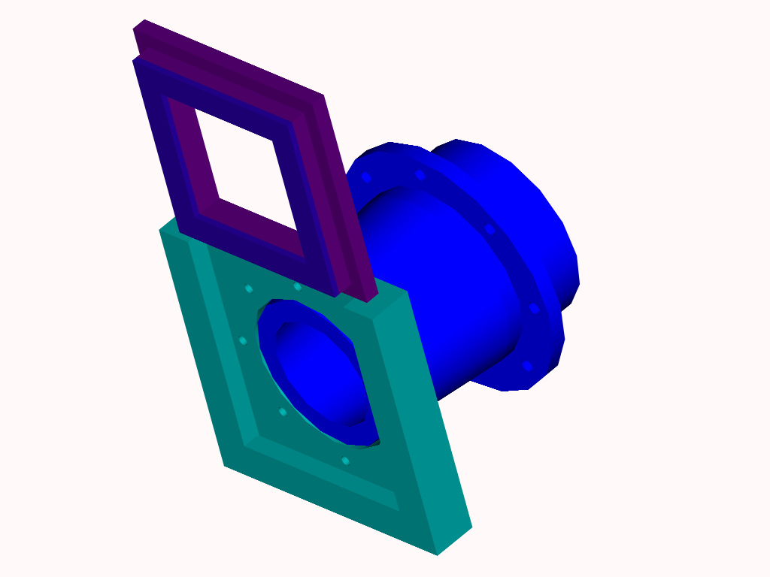
Figure 8. Re-imaging camera with filter holder and cartridge.

A light and dust proof baffle will be fitted between the filter and the CCD window. This will be done for all three re-imaging cameras.

3. Whole assembly

Figure 9 shows the whole assembly with one side of the sub-structure hull removed to show the dichroic beam splitter frames. The Aristarchos collimator is fitted hence the circular gap between it and the top plate.

In the near future finite element analysis will be employed to investigate the structural properties of the chassis. A ½ scale model of one half of the double octopod structure is currently being constructed. This should also give indications of the stability of the structure and provide the Sheffield engineers with fabrication knowledge for production of the final design.
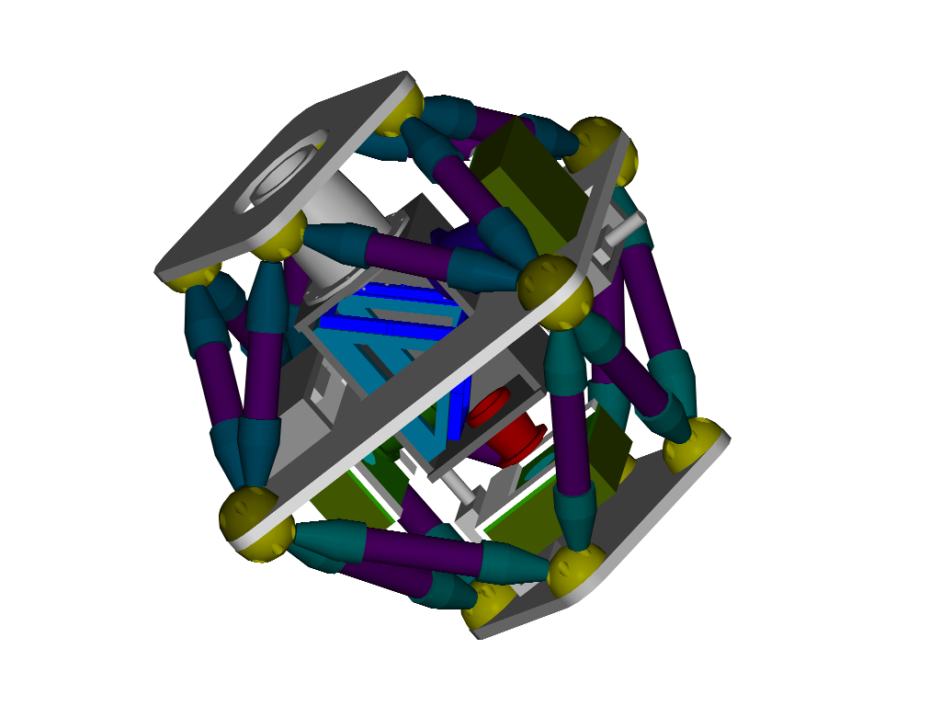
Figure 9. Ultracam. Double octopod assembly and sub-structure.

