To the edge of space

Alexander J Mackie
Supervisor: Professor Vik Dhillon
Project partners: Phil Carpenter, Phil Mahoney, Lawrence Wilkinson

Abstract:
A high altitude balloon attached to a payload has been sent up into the upper atmosphere, well into the stratosphere and a height of at least 35920m. The balloon burst and the payload parachuted back to the ground where it was successfully recovered by the team members. Temperature, pressure, humidity and tri-axial acceleration were measured during the flight and have been plotted and compared with models of the atmospheric temperature and pressure and simulations of the payloads ascent, descent and flight path. We have been able to confirm the exponential form of pressure in the atmosphere and verify the lapse-rate model of the atmospheric temperature.

Introduction:
High-altitude ballooning (HAB) is an increasingly popular hobby enjoyed by many across the globe. Typically, it involves sending a weather balloon to an altitude of ~30km (to the stratosphere), at which the balloon will burst, leaving the payload to parachute safely back to Earth. It is not an expensive hobby to undertake and allows for beautiful photographs of the Earth to be taken from what is described as the edge of space. Simple projects, where the only intent is to take photographs or video footage, are popular for beginners. More complex projects, which also wish to do atmospheric science and those that which to incorporate engineering and circuitry into the build of the balloon and payload, are common amongst Universities and experienced enthusiasts. This range of complexity has made HAB an ideal project with which to undertake to learn and refine skills in project designing, management and leadership.
As part of a group of four Physics and Astronomy Masters students and Professor Vik Dhillon, together as a group we decided that the success of this project was dependent on achieving five key requirements:
- A recoverable payload, photo showing the curvature of the Earth from space
- Pressure and temperature records
- Latitude and longitude and altitude as a function of time
- Legal launch, flight and recovery
- £500 budget
We also set three goals, which we would aim to achieve, but these were not regarded as essential for the project to be a success. They were:
- HD video of the flight
- Humidity records
- Live download of data
We split into two groups of two. As a team of two, we would come up with a design and strategy for the balloon, payload and project, all without conversing with the other group. This was to simulate the competition aspect found in most businesses and industry. We had approximately 12 weeks to design our high altitude balloon and payload. In December, we would then all come together and present our projects to the other team and to our supervisor. We would then decide which of the two designs we would build our project on.
This project also includes the development of a computer simulation that will, at first, simulate the balloons ascent and descent before being developed further to predict the flight path and final landing location of the payload. These simulations are important for understanding how to model complex environments, such as our atmosphere. These simulations are based on the 1976 US standard atmospheric models for pressure and temperature. By comparing the predicted data and real data, we can see how good this atmospheric model is and validate any assumptions made. This report will be split into two main parts: phase one and phase two. Phase one is everything done before Christmas, and it involves my-self and my team-mate Phil Carpenter researching, designing and planning our balloon project. It also includes the development of the ascent and descent simulation. Phase two is after New Year and details the building and development of the payload as well as the launch, results and development of the flight path simulation.
Phase one:
Simulation
To develop the simulation, we first needed to model the atmosphere that the balloon would be travelling in. After research, we found that the 1976 US standard atmospheric model ^{[1]} was a very accurate but simple atmospheric model. It splits the atmosphere into a number of layers based on the rate of change of the temperature. This rate of change is called the lapse-rate and is a linear change of temperature:
$$T= T_{b}+(\left(h-h_{b}\right)L_{b})$$
At each layer there are set values (layer denoted with a subscript number) for atmospheric pressure, density and temperature. Pressure can be derived using the barometric formula. The barometric formula is derived by equating the weight associated with a section of air, with the change in pressure associated with the height of that section. The atmosphere is assumed to be an ideal gas. The layers are defined by the following values:
Table 1: 1976 US standard atmospheric model base layer values
Layer (_{b}) | Base altitude, h (m) | Base lapse rate, L (K/m) | Base temperature, T (K) | Base pressure, P (Pa) | Base density, ρ (kgm⁻³)
0 | 0 | -0.0065 | 288.15 | 101325 | 1.225
1 | 11019 | 0 | 216.65 | 22632 | 0.36391
2 | 20063 | 0.001 | 216.65 | 5474.9 | 0.08803
3 | 32162 | 0.0028 | 228.65 | 868.02 | 0.01322

By using the equations above in the correct layer, plots of pressure, atmospheric density and temperature against altitude can be made. They can be seen later on in figures 5 and 6. The equations above tell us that pressure and atmospheric density have exponential forms with altitude. The temperature profile can be thought of as a combination of linear profiles related to each layer of the atmosphere. The first layer, from the ground until 11km, is known as the Troposphere ^{[2]}. Here we have a negative temperature lapse rate. The second layer is a minor layer known as the tropopause and is isothermal – the lapse rate is zero. This layer extends to around 20km, where we enter the third layer, which is the stratosphere. The stratosphere is the region where the ozone layer lies and interestingly we have a temperature inversion when compared to the troposphere (positive temperature lapse rate, so the top of the layer is warmer than the bottom). The reason for this is because UVb (315 nm - 280 nm) and UVc (280 nm – 100 nm) rays from the Sun dissociate O₃ molecules into O₂ and atomic Oxygen (O) in the Ozone. These dissociated molecules are more energetic and actually recombine lower down in the middle section of the stratosphere. The recombination releases photons, warming the region. An interesting feature of the stratosphere is that there is very little convective turbulence. This is because the temperature difference between the upper tropopause and the stratosphere is very small. This is something we intend to investigate and will also mean that taking photos and filming will calm at the highest altitudes.
With the pressure, atmospheric density and temperature modelled with altitude, we could now begin simulating the flight. To do this, we started with first principles and worked out the forces acting on the balloon. With the resultant force known, acceleration and then distance and velocity can be derived. To begin with, we made a number of assumptions to simplify the Physics involved. The first being; that the rate of ascent will be slower than the speed of sound (~340ms⁻¹ on the ground, ~290ms⁻¹ at the lowest expected temperature ^{[3]}). This is a fair assumption (We don’t expect to ascend more than ~5ms⁻¹) and it simply means the pressure inside the balloon ends up equalling the pressure of the atmosphere. Another assumption is the atmosphere, and the helium, are ideal gases. This assumption is a little shaky for the atmosphere as, for example, humidity in the atmosphere adds inter-molecular forces between the gas molecules and water vapour ^{[4]}. As an assumption for the Helium, it is okay as Helium is inert.
The lift that the balloon gets from the helium is due to the buoyant force. A given amount of helium inside the enclosed balloon will displace a certain amount of the atmosphere. The mass difference between the helium and the atmosphere it has displaced gives rise to the buoyant force. For the sake of simplicity, we have approximated the atmosphere’s molecular mass to be 28.97, due to the mixture of molecular concentrations in air. Helium has a molecular mass of 4, so the mass difference is equivalent to ~25 molecular masses. Therefore, the amount of lift is completely dependent on the amount of helium in the balloon. This difference in density is the basis of the buoyant force and can be thought of as the weight of atmosphere displaced:
$$F_{b}=ρ_{atm}V_{balloon}g$$
Where ρ is the atmospheric density, V is the volume of balloon and g is gravitational acceleration. As the atmosphere gets thinner with altitude, the balloon will begin to expand as the helium acts to displace the same density. Therefore, the radius of the balloon will expand with altitude. As we are assuming that the pressure inside the balloon is the same as the pressure of the atmosphere, the ideal gas equation can be rearranged to give the volume and thus radius (for simplicity, we are assuming the balloon to be a sphere at all times). We did also look into adding the elasticity of the latex balloon as a force countering the balloon’s radial expansion, but after researching the physics involved, we decided against adding it as it was far too complex and went against the simplistic ideology of the simulation.
This positive buoyant force is countered by the negative forces of gravity and drag. The drag equation used was:
$$F_{d}=\frac{1}{2}ρV^{2}AC_{d}$$
As can be seen, it is dependent on the atmospheric density (ρ), the drag coefficient of the object (C_{d}), area (A) and velocity of the balloon (V). The drag coefficient assumed in this simulation during the ascent was of a sphere (assumed shape of the balloon), where Cd = 0.47 ^{[5]}. The drag will act to reduce the balloon’s ascent to a terminal velocity. With all the forces accounted for, we could now calculate a resultant force. This resultant force could give us the acceleration of the balloon using Newton’s second law. With acceleration; the velocity and distance travelled could then be calculated using the forces of motion equations:
$$S=ut+ \frac{1}{2}at^{2}$$
Using all this information, we were able to begin building the simulation. To begin with; we set the amount of helium in the balloon as 0.546kg (3.21m³). This value was to give an ascent rate of ~5ms⁻¹ for a payload weight of 750kg and using a 1500g balloon. This information was taken from a guide on the UK High Altitude Society (UKHAS) wiki-page, which relates the amount of helium and the amount of lift. Starting at time (t) = 0 and using the initial conditions in the US standard atmospheric model for altitude (z = 0m), velocity (v = 0ms⁻¹), pressure (p = 101325pa), atmospheric density (ρ = 1.225kgm⁻³) and temperature (T = 288.15K), we followed the following step process to calculate the distance travelled in 1 second.
- Calculate radius, buoyant force, drag force and acceleration
- Calculate distance travelled in 1 second
- Calculate velocity
- Time increases by 1 second
- Calculate updated values for pressure, atmospheric density and temperature
This was repeated indefinitely until the balloon reached the ‘burst-radius’ determined by the manufacturer’s specification sheet. For a 1500g balloon, the burst radius is 4.72m. This simulation predicted this to happen at 32446m, with the ascent taking 1h 17m.
Once the balloon has burst, the payload will be in free fall and will require its pre-deployed parachute to safely fall back to Earth. In theory, simulating the descent is easier than the ascent, because now the balloon had burst; there was no buoyant force and only gravity and drag force to take into account. The mass of the system would change as well: All the helium escapes and sounding balloons are designed to shred completely at burst. To overcompensate for a ‘worst-case-scenario’ we have assumed only half the balloon shreds. The drag coefficient used in the ascent would need to be changed as well as the payload is object in focus. In the same process as the ascent, we modelled the descent using a step process, using initial values for pressure (829pa) and atmospheric density (0.0125kgm⁻³) as those when the balloon burst. The process was repeated until it hit zero altitude (We started the ascent from an altitude of 290m, as is the altitude of Sheffield. But as we did not know where the payload was to land, we will assume it is at 0m)
The landing speed of the payload is determined by the size of parachute being used. For safety reasons, we wanted the payload to land with a slow velocity. However, this had to be balanced with increased flight duration and the balloon having more lateral movement the longer it was in the air. We decided that a safe final descent velocity would be around 4.5ms⁻¹ (10mph). From the simulation, a parachute with a flat area of 1m² was capable of achieving this. The final descent velocity was predicted to be 4.81ms⁻¹, the descent lasting 57m and the overall time of flight (ascent and descent) predicted to be 2h 14m.
With the simulation complete, we could now predict the burst-altitude, the time of flight and rate of ascent. It is a really important feature of the project, because it can tell us how changes to the payload or balloon will affect a flight. For example, if we’re aiming for a specific flight time, we can work out how much extra helium may be required if the payload’s weight is increased due to the addition of a new component. It has also allowed us to set a mass budget for the payload at 650g. This was important, as we felt the need to keep the mass of the payload to a minimum for both safety and financial reasons (more mass requires more helium to achieve the same altitude). If we stuck to this mass budget, then we could say exactly what size of balloon, how much helium and the size of the parachute required to safely returning the payload. With the payload at the mass budget, we predicted that we would need a 1200g balloon, 3.28m³ of helium and a parachute of flat area 1m². This was predicted to achieve an altitude of 31730m and flight duration of 2h 30m.
Components
When looking at previous HAB projects, the first thing we noticed is most HAB’s followed a similar 3 component design; a balloon attached to a pre-deployed parachute attached to the payload via a tether. We decided that this was the simplest configuration and as it had been tried and tested in other ballooning projects, we would also base our balloon and payload around this design.
Recovering the payload was imperative to the success of the project, so we initially spent most of our time researching methods and components related to recovering the payload. A lot of HAB projects used radio as their method of tracking the payload in real time. This would require having a radio transmitter inside the payload and a receiver/antenna with the user on the ground. While this was the most common method of tracking we came across, there were two issues that we initially had with this form of tracking; it would be complex to set up (a lot of other projects use microprocessors and circuit boards, which went against our initial ideal of only using ‘off-the-shelf’ components), and that the receivers were far too expensive for our budget (for example, the Yaesu817, a receiver recommended by Tim Zarman, a Dutch balloonist was approximately 300euros ^{[6]}). We did look into devices called radiosondes, which are used with sounding balloons in meteorological surveys. Initially, we were very excited for the radiosondes devices, in particular the Vaisala RS80, as we found plenty of them available for £20 on eBay. The radiosondes are excellent for the project, because they are already designed to take scientific measurements that we were intending to do with this project. However, we would still need a receiver to track the payload as radiosondes don’t log their information and only transmit the data live via radio wavelength. We decided against the radiosonde after the cons of using them began to outweigh the pros. In particular, we were concerned with the battery life of the radiosondes (the Vaisala RS80 used a water battery, which apparently would only power the device for 90mins approx (ref?) and also we were concerned over the reliability of only having a live download of data with no back-up. Radiosondes work at low power radio band (typically 434 MHz 10Mw), but usually have no issue with signal due to their clear line of sight. However, if for whatever reason we lost sight or signal of the radiosonde, or if there was a fault on board, we could effectively lose the balloon and all our data completely. While the radiosonde did the tracking and science for a very low price, the high cost of the receiver meant there was no room for redundancy in tracking, so we decided against using the radiosonde.
The alternative method of locating the payload was to use GPS tracking devices. Although, compared to the radio tracking method, it does allow a stream of live data/ of the position of the payload, GPS trackers are much cheaper and fit our ‘off-the-shelf’ ideology for this project. We found two methods of transmitting GPS information – GPRS (radio/phone signal) and satellite. In particular, there were three devices which stood out based on their price and functionality. The first one we found was the Xexun TK102-2, which sent coordinate and altitude information via SMS text message. Therefore, the reliability of information being sent is dependent on network signal, specifically being in range of a radio-mast/phone network tower. Another SMS/GPRS based position tracker was a smart phone application called ViewRanger. The app was available for £2 and works on the three major phone operating systems (Apple, Android and Symbian). It had a tracking feature called BuddyBeacon that would send position information via GPRS to a server, which updated a map, allowing us to track its last known position. The other GPS tracking device was the Spot satellite GPS messenger. Spot was unique in that it passed on its positional information via communication satellite rather than radio, therefore eliminating any concern for the payload landing in an area of limited phone signal. Another feature of Spot was something called Spot tracker, which could be set to send positional information every 10 seconds to a server, which show the path the balloon and payload took in real time. Although very appealing, we had to decide against using Spot because it was far too expensive. The device itself cost 148euros and a subscription was required to use their tracker service (another 114euros). There was also concern with its ability to work within the payload, as we had found some reviews which stated the device would not work unless a clear view of the sky was available to it. Therefore, we decided to use a combination of the Xexun and smart phone with ViewRanger to give us the best chance of finding the payload once it landed. These devices would only inform us of its last known position, so we just needed them to work once they landed. Therefore, we decided to use two different network SIM cards, to improve the probability of landing within signal range. Also, by having redundancy in the tracking, if one device failed we would have a backup.
With tracking finalised, we turned our attention to temperature loggers. We needed a temperature logger that could operate and record to temperatures as low as -60°c, which is predicted from our lapse-rate temperature profile. We eventually secured a temperature logger from data-logging company Lascar as sponsorship of our project. The Lascar EL-USB-TC can record to -200°c using its thermocouple probe. A thermocouple probe works by having two dissimilar metals joined at one end. When the junction is heated or cooled, a voltage is produced which can be related back to the temperature. We used Lascar again for their humidity logger. The EL-USB-2 was both a humidity and temperature logger, but the temperature logger could only measure to -25°c.
Initially, pressure loggers were found to be expensive but we were able to find a small device by a Swiss company called the MSR145. It is a multi-logger and can record temperature, pressure, acceleration and humidity. However, with us already securing a free temperature logger and discounted humidity logger, we settled for a version of the device that recorded pressure, temperature and acceleration. Again, sponsorship allowed us to secure the device for a discount (half-price). With the MSR we could record the internal temperature of the payload. Acceleration was something we had not originally intended to investigate, but after researching the atmosphere we felt it could provide some interesting data relating to turbulent winds in the tropopause. The tri-axial accelerator would record the movement of the payload in 3 directions.
To record altitude, we had been in contact with a company called Polytronics about modifying one of their existing products, called Polytrace, to log the GPS and altitude information throughout the flight. The reason for modification is that most GPS chips do not work above 18km. International export regulations require that GPS chips must not work if travelling above 18, 288m (60,000ft) AND faster than 999 knots (518 ms⁻¹). Most GPS chips are programmed to not work if either of these is exceed, not just if both are exceeded. Therefore, we asked Polytronics to ensure their GPS logging device would work above 18km.
For taking photos of the curvature of the Earth, I donated my Canon A430 camera to the project. The camera’s resolution is 4 Megapixels, which is ideal for the project as higher resolution cameras reduce the pixel size as a means to fit pixels onto the CCD. A community online, called CHDK, develop firmware hacks for Canon cameras and by installing this onto the camera SD; it allowed us to set up time-lapse photography. We then looked at video cameras, as by now we felt we had saved on the budget to achieve the goal of videoing the flight. There were a number of concerns related to which video cameras were suitable to the job, specifically; battery life (last more than 3 hours) and resolution (High Definition for best quality). We got into contact with a company called Tachyon, who make cameras designed to cope with extreme conditions. Their camera (Tachyon XC-HD) appealed to us because of its 6 hour battery life and is high-definition (720p) as standard. They were happy to send us a camera, as well as a 32GB SD card, for free in return for publicity.
With the contents of the payload accounted for, we looked at the size of balloon and parachute required for the project, as well as the amount of helium required. We assumed the weight of the payload box to be 100g, and combining the weights of our payload components; we had a total mass of 620g for which we could use to determine the size of balloon required. We calculated from the simulation that 3.28m² of helium was required to achieve an average ascent rate of 5.5ms⁻¹. The helium was to be sourced from the workshop at the University of Sheffield Hicks building. We would still use the 1200g Totex latex balloon, which was best suited for price to achieve a height above 32km. Using the simulation we worked out that to achieve a safe, slow descent rate of 4.8ms⁻¹, a 42” X-type parachute was required. In the simulation, we said this had a flat area of 0.74m². The X-type was designed to reduce lateral movement when deployed. The balloon was to be sourced from Random Solutions, an internet shop for HAB projects. Our final payload design is outlined below, with pricings and key information:

Table 2: Phase 1 final payload component list and information
Device | Polytronics polytrace | Xexun TK102-2 | Lascar EL-USB-TC | Lascar EL-USB-2 | MSR 145 | Tachyon XC-HD | Canon A430
Key features | Customised firmware  Logs long/lat/alt to 50km  Works to -40°c | Primary tracker  Transmits GPS and altitude on request | External probe operates to -200°c  Memory capacity for 9 hours of data | External probe records humidity from 0% to 100% | 0-2500mbra absolute  Acceleration to ±10G | Recording batter lifetime of 6 hours  High definition – 1024x720 | 4 Megapixel camera  CHDK firmware for time lapse photography
Price (£) | 160 (inc SIM card) | 74 | free | 25 | 86 | 25 | free
Weight (g) | 100 | 50 | 70 | 70 | 20 | 160 | 250

This gives the total cost at £499 and the weight as 780g (including the parachute at 50g)

Results
We had the design review with Professor Vik Dhillon and the other team on the 13th December 2010. After putting forward both strategies, we conversed and decided on the best configuration we can build for our budget. We agreed to use all the components that we sourced for free or had heavily. The other team had bought a Vaisala RS-80 already and decided to use radio to track and download the data live. They also found an altometer made by Garmin which was confirmed to track position and record altitude above 18km. Both teams had established that a 1200g balloon was required for both payload set-ups. The final list that we came up as a team is shown below, along with the total cost and weight. We felt at the time this was the best combination of what both teams had come up and could deliver the best results for the science and photography as well as having enough redundancy in case anything failed during the flight. We also decided to pencil a launch for just before the Easter break, which was the last week of March or the first week of April. That gave us two months after New Year to order everything, build the payload and test our components.

Phase two
Now with all four of us working together, we set out to finalise the components for ordering. We were kindly donated an iPhone to use for free by Dr. Littlefair, so we agreed to include this with the ViewRanger app as a back-up GPS tracker. We had since decided against using the Radiosonde. There were two reasons for this. We felt that because having a live download of data was only a goal, it was therefore only going to be a back-up to the other scientific devices. This meant it was hard to justify spending so much on the radio receiver required. As it had been bought and was in possession by the University, it had been suggested using the radiosonde in a second launch if we could afford a secondary balloon and if we could borrow/rent a receiver, possibly through someone within the UKHAS. We also opted out of using the modified Polytrace GPS logger. Peter Evans, who we were in contact with at Polytronics, could not guarantee having the device modified and ready by the time we intended to launch in late March/early April. With the payload spec finalised, we could also go back to the simulation and determine the size of balloon and parachute required. Originally we opted for a 42” X-type parachute, but decided that a 4ft standard parachute would be better for the new payload weight. The simulation also confirmed that the 1200g balloon would be fine for the new payload weight. We ordered two Pay As You Go SIM cards for the Xexun and iPhone and they would use VodaFone and O₂ respectively. We found that all the major phone networks have similar network range ^{[7]} so it didn’t matter which one we used. With everything confirmed, we ordered the components and then began to work on building the payload.

Build
Trevor Gamble was our contact in the Hicks building workshop and helped us source materials and tools for building the payload. We were able to get hold of some leftover Styrofoam material free of charge, as well as soft foam for padding. Both materials are ideal for building the payload box out of, particularly Styrofoam because it is light-weight and a very good insulating material. The second feature is important, because we did not want any of our electronic devices to fail because of the long exposure of the payload to the cold conditions in the upper atmosphere. While discussing the payload shape, we envisioned a shape that could use the wind to stabilise the payload’s natural impulse to spin. The theory was that it would work like a weather-vane, having unequal surface area distribution. The wind would always act to the side with the most surface area, countering any impulse to spin and keeping the payload pointing in one direction for most of the flight. A mock of the shape we intended to build is shown below:

Figure 1: CAD drawing of payload box shape
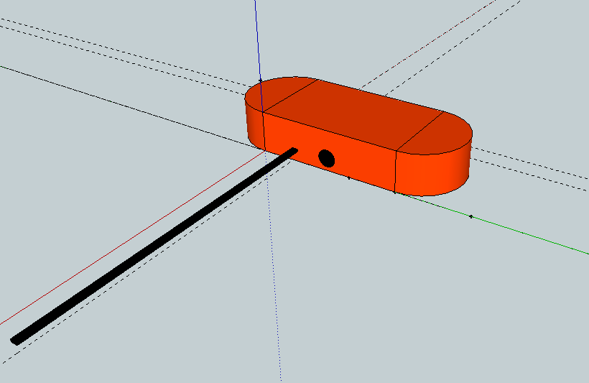
We began to build the middle section of the payload first. We simply measured out sections of Styrofoam and glued them together to make a cube. Its external dimensions were measured to be 15.8cm x 16cm x 21.0 cm, with a wall thickness of 2.4cm. These dimensions fit around the placement of the components, as shown below:
Figure 2: Top down view of top compartment of payload box
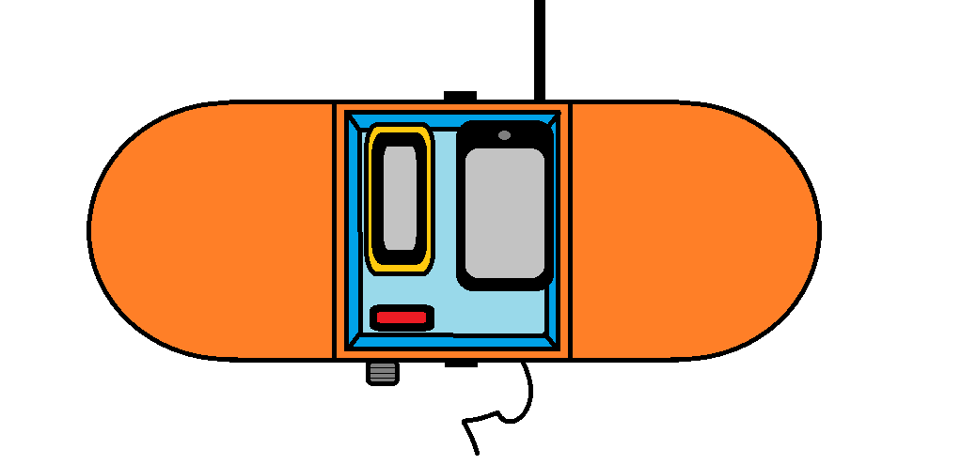
Garmin eTrex
iPhone
Xexun TK 102-2

Figure 3: top down view of bottom compartment of payload box
Canon A430
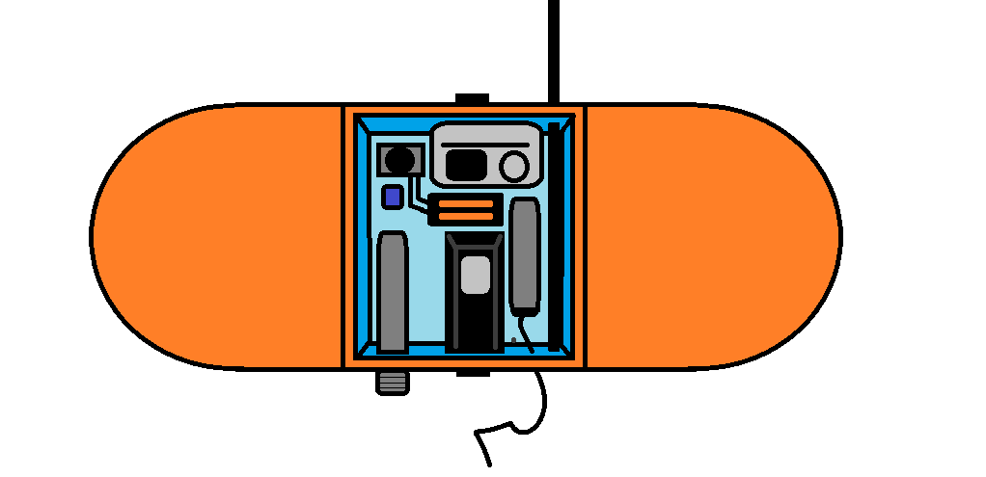
Thermocouple probe
Lascar EL-USB-TC
Tachyon XC-HD
Lascar EL-USB-2
MSR 145
Buzzer
By making the middle section as compact as possible, it would hopefully retain heat and keep the electronic devices from falling below their operating temperature. As can be seen, we decided on a two-tier system; with the cameras and the scientific equipment at the bottom and the GPS devices on the top. This not only did this conserve space, but it also meant the GPS devices had less ‘material’ between themselves and the sky; maximising the chance of locating positioning satellites. A section of soft foam was used to divide the two sections and we also placed soft foam on the bottom of the box to absorb the impact force upon landing, thus making it safer. With a lid fashioned for the box, we worked on making the wings. To do this we took some soft foam and curved it round and glued it to the sides. We then measured out top and bottom parts out of Styrofoam and glued them in place. Again, we added some soft foam to the corners of the wings. We then coated the entire payload in orange gaffer-tape. This gave the entire payload structure strength, making it robust enough to withstand the landing impact. It also made the payload water proof and by being bright orange, it would make it stand out wherever it landed. To make the payload even more visible, we purchased four flashing LEDs that we placed on both sides of the payload. This would help to locate the payload, should we be required to locate it in low light conditions. We also made a simple battery-switch-buzzer circuit, which would be placed inside the payload and be used to help find the payload if we could not see it. Trevor also made a 50cm fibre-glass rod with a University of Sheffield logo attached to the end that we stuck out the end of the payload. This would serve as publicity for the University and we placed it such that it was slightly to the right of the cameras field-of-view, allowing us to still take clear photos of the curvature of the Earth.
We had originally reserved a 1200g Totex balloon with Random Solutions at the end of phase one. However, they had since forgot and sold the balloon. We could not source another 1200g balloon in time; there were none available from importers in the UK and the time scale and shipping costs meant ordering overseas couldn’t happen. Random Solutions did however have two 1600g balloons available. After getting a small budget increase, we agreed to purchase as no other alternatives were available. While disappointing to go over budget, it was the only option available and having two balloons meant we had redundancy should one of our balloons be damaged or be destroyed during the Helium filling procedure. It also gave us the opportunity to have a second launch using the radiosonde if a receiver could be obtained for free. The advantage as well of having a 1600g balloon meant we could achieve a higher altitude. 1600g balloons are bigger and thus can expand more before they burst. In the purchase we also managed to secure nylon kite string, which we would use to secure the balloon to the parachute and to the payload. The string is designed to hold up to 35kg and we made the total length of tether around 2m. We had seen in other HAB videos that if the tether was too short, the payload bounces as it is being dragged up by the balloon. By having a longer tether it should also allow the parachute to operate unaffected by the shredded balloon as it falls back to Earth.
Simulation
We wanted to improve our simulation from phase one to not only model the ascent and descent of the balloon, but also predict where it will land. Balloon flight times are typically 2-3 hours and their flights are decided by the wind, so they can travel hundreds of kilometres in that time. Britain is relatively narrow so if launched on a day with a westerly wind, there would be a good chance of the payload landing in the North Sea. Therefore we worked on getting our simulation to predict the lateral movement of the balloon and payload based on live wind data. This would mean that we could check the simulation a day before launching and predict its final landing spot. We would therefore only launch the balloon if it landed away from major cities and far away from the coast.
To do this we needed up-to-date wind speed data for England. We found that the NOAA (National Oceanic and Atmospheric Administration) Operational Model Archive and Distribution System (NOMADS) ^{[8]} provided this information. In particular, we used their GFS (Global Forecast System) 0.5 x 0.5 degree data set, which we sought ASCII data for wind speed in the east-west direction (ugrdprs), wind speed in the north-south direction (vgrdprs), geopotential height (hgtprs). This information can be attained for a given longitude, latitude, altitude and time. The half degree resolution covered most of England, so we only needed to specify one location. We took the data for all altitudes (the maximum being 47688m), and specified the intended time of launch. This was all done through DODS URL commands (see appendix [1] for example).
With wind data available, we could now begin to build our new simulation. The two sets of wind data had wind speeds for a given altitude, so we took the wind speed to be a constant value above each altitude level. Compared to the ascent and descent simulation, the wind speed data had direction, so we treated them as vectors. The two sets of wind data were split into x-axis data (east-west) and y-axis data (north-south). East and north were taken to be positive, and west and south negative. Wind speed can be converted into a force using the drag equation used in the previous simulation. In this case, the velocity is simply that of the wind and the area it is acting on has been assumed as the largest side of the payload. Drag was incorporated into the model as well, acting in both the x and y axes, against the wind and slowing the payload down until it reached a terminal velocity. Like the ascent and descent simulation, once we had a resultant force; an acceleration in both x and y can be derived. Acceleration gave us distance and thus a new velocity. This step process was repeated until the burst altitude, which is predicted in the ascent simulation (our original prediction was 32.5km). The step process was repeated for the descent, although with a smaller total mass as the Helium is lost and the balloon is assumed to half shred. The distance travelled in the x and y axis was then plotted and this showed the path of the balloon during the flight. The plot was then placed over a distance calibrated map, with the launch site positioned under where the flight path stars. This showed us where we expected the payload to land, which would give us an idea where to travel once the balloon had been launched, saving time and improving the chances of locating the payload. The simulation used to predict the flight path the day before we did our launch is shown below:
Figure 4: Predicted flight path from Surprise View
Path in blue, burst point in red and actual payload location in green
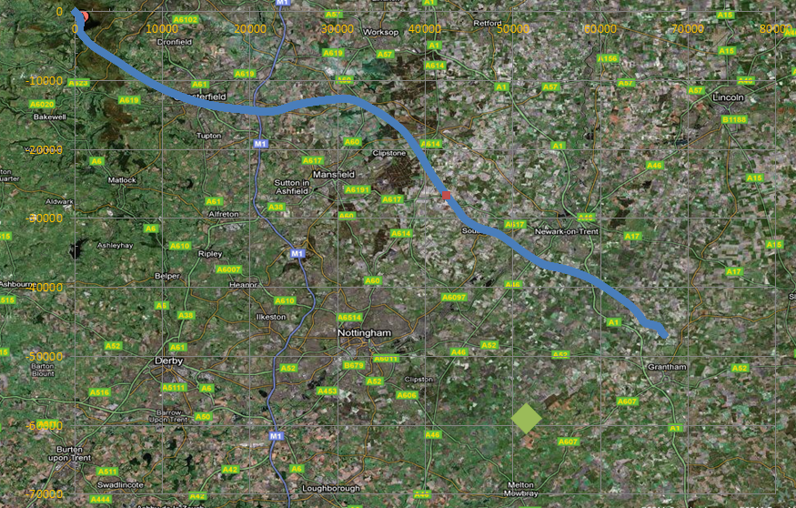
The location of where we found the payload is highlight in green. As can be seen, the prediction made by the simulation was fairly good, achieving the right direction. The approximations used could be refined to improve the simulation, for example the drag coefficient and the area that the wind is acting on.
Testing
Before launching we put the components through a number of tests to see how they would perform over the expected flight duration and conditions. The easiest test to do was to test the battery life of the products, which meant leaving them on under working conditions for three hours. The camera was set to run for three hours, taking a picture every 10 seconds. The CHDK firmware makes the camera very efficient, so even after three hours the camera was displaying near full battery life. The Tachyon was taken on a bike into the peaks and filmed for several hours without fail. The Lascar data loggers and the MSR were subjected to a 3 hour test inside a freezer, testing both their durability and measuring capabilities. The iPhone was the biggest concern for battery life, but came through the 3 hour batter test. We also tested each components functionality and familiarised ourselves with the products. This involved using and testing them such as, for example, taking the iPhone with the ViewRanger app and going for a long walk while another member of the team tracks the progress using the Buddy Beacon service. From this we learnt that the iPhone screen had to stay on for the duration of the flight. The Garmin was taken into the Peaks and logged the GPS data for the duration of the day. The buzzer was also tested for 3 hours.
We also tested the parachute and payload by dropping it off the Hicks roof with an equivalent weight of the real payload inside. This was only from around 12m high, but the pre-deployed parachute opened up nicely and the payload came through the test unscathed.
Launch
We applied for launch from just outside of Sheffield at Surprise View in accordance with the Civil Aviation Authority (CAA) for a two week period (28th March – 8th April). We eagerly looked at the flight predictions every day. For most of the two week period, the wind was taking the payload into the North Sea, until the last two days (7th and 8th April) that the wind became southerly, taking the payload into the midlands. With everything getting checked over one last time, we prepared ourselves to launch on the 7th. We had all the components set up to the following: Camera taking photos every 10 seconds, Pressure, internal temperature and acceleration logging every second, external temperature and humidity every minute. We arrived at Surprise View just after 9am and unfurled the balloon. Trevor had custom made filling-nozzle, which fit the bottom of the balloon perfectly. We used cable ties to keep everything secure and began to fill the balloon. We also filled a 5l bottle with 3l of water and attached it to the balloon. When the desired amount of Helium was inside the balloon it would begin to lift the 3kg weight attached. The Nozzle lift calculated to lift our payload was 3.6kg and with the filling nozzle weighing 600g, we required a 3kg weight, which once lifted would inform us that the correct amount of helium had been filled. Other members of the team put the payload together, checking for the last time that everything was on and working. The lid was taped shut and we prepared to launch. Unfortunately, when notifying the local air traffic control tower of our launch, they forbid us to launch. Therefore, we had to cancel the launch for legal and safety reasons. The next day however, we gained full approval from the air traffic control and got ready to launch again, albeit with the second 1600g balloon (the other one had been ruined). With conditions perfect, we launched the balloon at 11.07. With the simulation predicting the balloon to land south-east of Nottingham, we set off. We arrived in the area at around 12.30 and such were the excellent conditions of the day, we were able to see the balloon in the sky. Based on our predictions, the balloon would be approaching its highest altitude at this time. Therefore, the diameter of the balloon would be close to 9m. This makes it just about visible to the naked eye, given clear conditions. At around 13.00 the balloon disappeared from sight and we assumed that it had burst, which would have matched with our predictions. We persistently made contact with the Xexun GPS device, as well as checking the Buddy Beacon service from the ViewRanger. The simulation predicted the descent to take approximately an hour, so we didn’t expect signal from either device until later on. However, around 13.30 we got reply from the Xexun specifying its coordinates: 52.8495N, 0.893W. We put these coordinates into Googlemaps and saw it was only 17 miles from our current location. We went to the location specified by the Xexun and then began to search for the payload. The area was all farmland, which was exactly where we wanted the payload to land. We eventually noticed the orange payload lying in grass field next to a public footpath and recovered it. The payload was completely intact, including the fibre-glass rod attached to the side. Interestingly, balloon had completely shredded which was exactly what we wanted. We opened up the payload and were eager to see the results we had produced. The Canon camera worked perfectly and had taken over 1400 photos of the entire flight. Sadly the Tachyon had built up condensation on its lens, which meant the video footage was heavily blurred for most of the flight. Another disappointment was the Garmin altometer, which had turned itself off, so we had not official verification on the altitude we reached. We downloaded the data for the temperature, humidity and pressure loggers once we got back to Sheffield. The ViewRanger had no signal so that was why it was not updating its location. The Xexun was also having trouble with signal, so it was lucky that we made contact with it when we did.
Results
Figure 5: data plotted against elapsed time
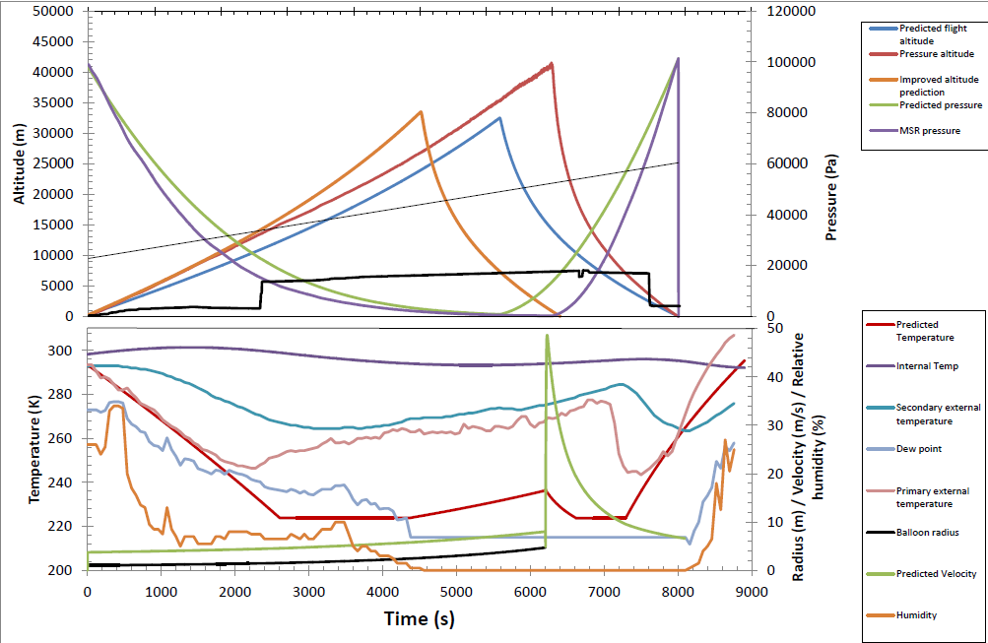
All the data we took from the flight can be seen in the following four plots. Firstly, we plot the data against elapsed time and the results can be seen in figure 5. Also shown in figure 5 are the predicted data for pressure, temperature and the ascent and descent based on the US standard atmospheric model. Because the altometer didn’t work during the flight, we have had to derive the flight altitude from the pressure values taken by the MSR. This was done rearranging the barometric equations used in the simulation to derive altitude from a given pressure. Comparing the predicted altitude with the pressure-derived data, one can instantly see that we achieved a far greater height than anticipated. Based on the pressure data, we reached a height of 41239m, but taking into account the error associated in the MSR (2.5milibar or 250 Pa), we can put a lower limit saying that the balloon we to at least 35920m. In the last simulation done days before the launch, it only predicted us to achieve an altitude of 32520m. Comparing the two data sets further, there are differences in the rate of ascent and descent. The real and predicted data share a similar rate of ascent for the first 400s (6m 40s), but then the balloon data achieves a faster ascent rate and keeps this for the rest of the ascent. The predicted data shares similar form but simply rises slower. I believe the reason for this could either lie with the amount of Helium we actually put in the balloon (more than we had in our predictions) or the values we have used in calculating the drag force. A post-launch modification to the simulation is also shown, where the amount of helium was increased to represent slight over filling. This was only marginally increased, from 0.9kg to 1kg, but as can be seen the rate of ascent follows the observed ascent more closely. We cannot achieve the same altitude as in the real data, because the balloon specifications state that it should burst at 5.25m. By filling up with more helium, the burst radius is achieved sooner and the overall burst altitude is lower. Therefore, it is quite unusual that our balloon reached as high as it did. It must have exceeded its burst radius for some time, achieving a height far greater than it should have. In the descent, the real data shows a much sharper descent than in the simulation. In the simulation, we assumed only half the balloon would shred, so as it is carrying more weight; it should have similar, if not sharper, descent than the real data. Again, this could be explained in the values assumed for the drag, possibly that the drag coefficient chosen should be smaller. The modified simulation shows a better fit to the descent profile, with the drag coefficient modified from 1.5 to 1.2. 1.5 was the given drag coefficient for a parachute, but possibly it did not apply exactly to our parachute. The predicted flight duration does matches almost perfectly with the actual flight duration, although the modified simulation now has much shorter flight duration.
The predicted pressure and measured pressure are also on figure 5. They share similar forms, but don’t over-lap due to the different altitudes achieved at different times between the real data and the predicted altitude data. The pressure data is best compared with the predicted pressure in figure 6, as these show the form with altitude and it the use of the US standard atmospheric model can be validated properly.
Also plotted is the iPhone ViewRanger altitude data. This has been shown for completeness. It is not really designed to calculate altitude with much accuracy, nor does it even log the information past 7km. This is due to the aforementioned problem that GPS chips have with altitude.
In figure 5, we have plot temperature, velocity, humidity and balloon radius as a function of elapsed time. Predicted temperature follows the lapse-rate model described in the simulation section. As can be seen is its linear decrease in the troposphere section of the atmosphere, its constant value of 216.5K in the tropopause and its linear increase in the stratosphere. It then goes through these sections in reverse during the descent. When we were downloading the data taken during the flight, we found that the thermocouple temperature probe had encountered a problem and the data it took was completely off. This was disappointing as it was the primary external temperature probe and the only device capable of measuring the lowest temperatures of the atmosphere. The Lascar humidity probe also measured external temperature, but was only capable of measuring to -25°c (248.5K). This secondary external temperature probe data shows similar form to the predicted temperature profile, displaying an initial decrease in external temperature followed by an isothermal period and then a gradual rise. However, as mentioned it encounters its own limitations at 264K (-9.5°c), so we cannot verify the lowest temperature that should be encountered at the top of the troposphere. The probe itself was only half sticking out of the payload, so there is a possibility that its temperature measurement has been influenced by the heat from inside the payload. The temperature inside the payload was recorded by the MSR and can be seen to be reasonably constant. There is an initial increase in temperature, which would have been due to taping the lid shut and having all the equipment operating. It then begins to cool as the payload travelled through the troposphere and tropopause, until warming again in the stratosphere. These temperature fluctuations were relatively minor, with the largest (301.4K) and smallest (293.4K) internal temperature readings differing by only 8K. With this is mind, we took the primary external temperature data and noticed that its shape was similar to that of the secondary external temperature data, albeit inverted. For completeness, I have added the primary temperature data which was been inverted and scaled so its starting temperature is that of secondary temperature data. There is remarkable consistency with the primary temperature form and the predicted temperature profile for the first 1800s (30mins) of the flight. It then begins to deviate. The thermocouple probe we used can measure to -200°c, so it is difficult to blame the limitations of the probe for this deviation. However, as it rises it then drops abruptly at 7000s and begins to follow the predicted temperature profile closely again, deviating only at the very end. We tested the thermocouple probe days after the launch and confirmed that the probe we used was working correctly. We therefore think the problem may lie in how the probe was connected to the logger; either the connection was loose or by having it inserted in ‘reverse’ thereby explaining the inverted temperature profile.
Relative humidity is a measure of the amount of water vapour in a mixture of air. It is measured as a percentage of the saturated vapour pressure (saturation referring to the state of the water). A relative humidity of 100% would mean travelling through cloud. On the day we launched, there were no clouds in the sky at all, so it was not expected to measure any substantial humidity in the atmosphere. In the humidity profile, there is a peak 300s into the flight. Being only a few minutes into the flight it would have been obvious if it was any thin cloud. Possibly, being early in the day when we launched and the ground temperature increasing, this relative humidity peak is a measure of the evaporating dew from the field that we launched in. For the rest of the flight, the relative humidity generally decreases with temperature and pressure, which is expected. Towards the end of the flight, the relative humidity reaches 0%. Above 20km, the atmosphere does not hold any water and clouds cannot form, which is backed up by our data.
The predicted growth of the balloon’s radius is also displayed in figure 5. As described earlier, the radius of the balloon increases with altitude as the atmospheric density decreases. Its growth follows that of atmospheric density, which is of exponential form. It reaches its maximum radius of 4.7m before the balloon reaches its limit and bursts. The dew point data has also been plot, which is the temperature at which, at constant pressure, water vapour to condense into water. The predicted velocity of the payload has also been plot showing the gradual increase in ascent speed. It then increases rapidly after the balloon has burst and gradual decreases to a near terminal velocity.

Figure 6: data plotted against altitude
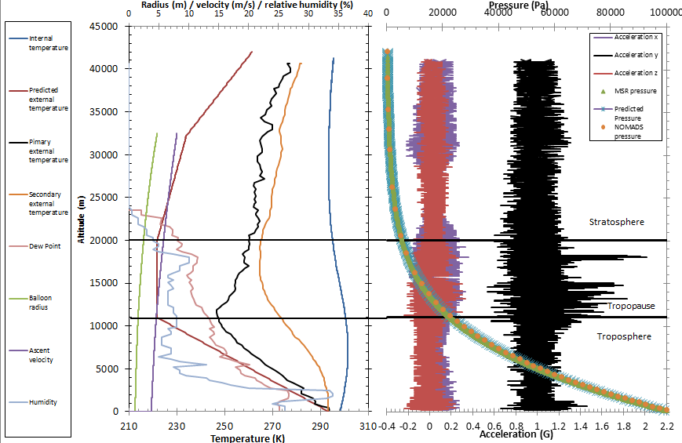
Figure 6 shows the data and predictions plotted with altitude. This represents the changing atmospheric conditions throughout the atmosphere. The altitudes at which the troposphere, tropopause and stratosphere boundaries lie have been added to give an idea of what is happening in which atmospheric layer.
Using the derived altitudes from the observed pressure, the observed pressure has been plot with altitude in figure 6. Also shown is predicted pressure using the barometric equation and US standard model. It is almost a perfect fit between the two data sets and when we also add the NOMADS pressure values used in our landing simulation there is identical correlation between all three data sets. As our altometer didn’t work during the flight, we can’t directly compare our data with the predicted pressure and altitude. We have derived our altitude from the pressure, so what this plot serves is validation of the barometric equation and its use in our simulations.
Also in figure 6 is the accelerometer data. The accelerometer was tri-axial, measuring in the x, y and z axes. Based on how the MSR is placed determines the relative directions of these three axes. The placement of the MSR in the payload meant that the x and z axes were lateral directions of the payload and the y axis was vertical direction of the acceleration. The initial accelerations in all three axes are relatively large at the lower altitudes. This was because when we launched the payload there was a lot of movement through handling the payload and then once launched, we observed the payload swing akin to a pendulum. One would assume this to continue initially until the wind allowed it to fall into a gentle rotation. The acceleration then tells us the movement of the payload was relatively small until the balloon reached the tropopause. Here the acceleration in all three axes increases, especially in the y axis which reaches acceleration changes of nearly 1G in this region. This could be evidence for convective winds that lie in the tropopause. These winds are caused by the temperature difference between the upper troposphere and the tropopause. According to NOMADS, winds in this region reach speeds of 35mph. Once the payload has moved into the stratosphere, the acceleration changes in the x and z axes gradually reduce, while the y axis acceleration remains constant. The stratosphere is a much calmer region of the atmosphere. There is no convective turbulence due to its temperature inversion compared to the troposphere. This is highlighted by our data as all axes experience small acceleration changes in this region.
Figure 6 contains temperature, humidity and velocity information with respect to altitude. The predicted temperature profile shows how the atmosphere’s layers are defined. The troposphere ends when the atmosphere becomes isothermal at 11km and the tropopause ends when there is a positive lapse rate at 20km. As described, we had shortcomings with measuring external temperature so we cannot accurately say where these boundaries are based on our data. Because there is no certainty that our primary external temperature data is valid and also because the secondary external temperature probe is limited to its lowest temperature measurement, we cannot confirm that, where these two profiles appear to show isothermal temperature, it is because it is or because of apparatus limitation/error. The internal temperature profile again shows that it changes little with altitude.
The predictive balloon’s radius displays very slow growth until it reaches the tropopause, increasing at a faster rate until it bursts. The humidity displays some chaotic characteristics, with an overall decreasing trend laced with maximums. As previously mentioned, the maximum value is reached shortly after launch at 2.5km. There is a very rapid decrease with two more noticeable peaks at 6km and 18km. These peaks only reach percentages of 13 and 11 respectively. With such low values, it is difficult to attribute these to anything but anomalous regions of increased water vapour being transported by air. At 25km the humidity drops to 0, where the atmosphere is too thin to carry any water vapour.
The camera worked perfectly during the flight, taking over 1000 photos. From the photos we can see that the payload span, which meant our weather-vane style payload didn’t work exactly like we planned. However, what it may have done is reduced the overall spinning, as from the photos we can see from the placement of the Sun that the payload rotated and returned to its original position every 3 photo frames (30 seconds). The photos contained time information, so we have confirmation of when we launched, when the balloon burst and when it landed. Looking at the photos, it is around 40 minutes into the flight that the darkness of space becomes apparent, which compared to our altitude data puts this at 10km. We have pinpointed 13.05 as the time when the balloon burst, as the camera takes photos as it tumbles. As we launched at 11.07, this burst would have happened after 7080s, matching up with our altitude profile in figure 5. In some photos the east coast of England can be seen, specifically the Wash and the top half of Norfolk. In the far distance there is a possibility that we are viewing some land mass, which could be Belgium or the Netherlands, although due to the haze of the atmosphere this could be also be clouds in the North Sea (See appendix [2]). The landing of the payload can be confirmed at 13.36, making the descent a mere 31 minutes. If it achieved a height of 42km as the pressure suggests, this meant its average velocity during the descent was approximately 84kmh⁻¹. The entire flight lasted 2 hours and 29 minutes.
The video footage was sadly impaired by condensation built up on the lens. From watching the footage, it begins to build up after 30 minutes and eventually becomes so bad that the curvature of the Earth can barely be made out. The reason for this is because the camera was too rugged. The camera is designed for the most extreme conditions and is waterproof to 30m. This meant that no moisture from inside the camera could escape. With the lens exposed to the cold atmosphere for most of the flight, the moisture in the camera condensed on the lens.

Conclusion
Looking back to our launch, the conditions unto which we launched the balloon and where it landed were ideal and the time it took recover the payload was very impressive. I believe this was a testament to the months of preparation that went into the launch. Although there have been a few disappointments regarding some lost/corrupt data, we have still managed to perform a lot of science. Figures 5 and 6 show all the important data that we produced in simulations and recovered from the loggers. With the payload data, we’ve been able to improve the assumptions used in the ascent and descent simulation, suggesting we over filled the balloon slightly and that the drag coefficient of the parachute was slightly wrong. With our data we have verified the equations used and model that we have based our predictions on, thereby validating the US standard model 40 years after it was first proposed. If we had reliable temperature data it would be been worth confirming the temperature lapse rate in each atmospheric layer.
Every project, especially those performed for the first time, encounter problems that cannot be planned for or avoided. It is still a mystery as to why the altometer did not function during the flight. The way it was placed inside the payload makes it very hard to have any its buttons accidently pressed. The corrupt thermocouple temperature data could have been caused by incorrectly fitting the probe. In both instances more care would be required for future launches, with another member of the team who could double-check on the payload set-up right before launch. The condensation build up on the video camera lens was something we could not have planned for, although maybe if we had subjected it to a long-term low temperature test we may have picked up on it. While some devices were tested in freezers, we didn’t test every component so in hindsight that is one change that we should have made. That is not to take away from the overall success of the project however.
There are a number of interesting ways to improve and expand the project. The radiosonde could have given us fantastic data, considering it is designed to take measurements of temperature, pressure and humidity. The use of radio to track and download live data would have been a completely different, but interesting, way undertaking the project. Other projects incorporate servo arms in their payloads, which are controlled from the ground via radio. These servo arms have the camera attached and allow the camera to move and change its view. With weight and money a concern, it is disappointing that a number of photographic opportunities are missed by have the camera fixed on one view point. The servo arm would eliminate that and allow pictures of the curvature of the Earth, the ground and the balloon bursting from one launch. With regards to the science, in another launch it would be good to get altitude information. It would allow us to properly confirm how high the balloon got and also allow us to properly compare with our predicted data. With a larger budget, I would have liked to have investigated primary cosmic rays in the upper atmosphere. Possibly their energies or count-rate could have been measured using a detector. Also measuring the UV flux in the atmosphere, especially in the Stratosphere were UVb and UVc are absorbed could have expanded the science aspect of the project.

References
[1] http://modelweb.gsfc.nasa.gov/atmos/us_standard.html
[2] http://csep10.phys.utk.edu/astr161/lect/earth/atmosphere.html
[3] http://en.wikipedia.org/wiki/Speed_of_sound
[4] http://www.engineeringtoolbox.com/humid-air-ideal-gas-d_677.html
[5] http://en.wikipedia.org/wiki/Drag_coefficient
[6] http://hollandshoogte.wordpress.com/news/page/2/
[7] http://ukmobilecoverage.co.uk/
[8]http://nomads.ncdc.noaa.gov/guide/index.php?name=advanced#adv-gdsascii

Appendix
[1] Example guide of retrieving ASCII data from NOMADS:
0. Useful url for info: http://nomads.ncdc.noaa.gov/guide/index.php?name=advanced#adv-gdsascii
1. Go to: http://nomads.ncep.noaa.gov/
2. Click on "GFS 1.0x1.0 Degree - OpenDAP"
3. Click on latest forecast at bottom: e.g. "30: gfs20110406/: dir"
4. Click on latest "gfs_*z:" link, e.g. "3: gfs_06z: GFS fcst starting from 06Z06apr2011, downloaded Apr 06 10:35 UTC info"

5. Cut and paste base url under "OPeNDAP/DODS Data URL:", e.g.
"http://nomads.ncep.noaa.gov:9090/dods/gfs/gfs20110406/gfs_06z"
This is 6am forecast on 6th April 2011.

6. Now add the parameters to download the data. Parameters we want are
i. ugrdprs (m/s wind speed in E-W direction)
ii. vgrdprs (m/s wind speed in N-S direction)
iii. hgtprs (geopotential height in m, i.e. altitude corresponding to pressure
1000 975 950 925 900.. 7 5 3 2 1)

Longitude: 0.00000000000°E to 359.00000000000°E (360 points, avg. res. 1.0 deg)
Latitude: -90.00000000000°N to 90.00000000000°N (181 points, avg. res. 1.0 deg)
Altitude: 1000.00000000000 to 10.00000000000 (26 points, avg. res. 39.6)
Time: 06Z06APR2011 to 06Z14APR2011 (65 points, avg. res. 0.125 days)

Values for brackets:
Latitude: x = 53.3+90.0 / 1.0 = 143
Longitude = 358.4-0.0 / 1.0 = 358
Altitude - we want all values, so 0:25
Time = [Number of hours between now and 06:00 on 06 April 2011) / 24] / 0.125 = 4 for 18:00 on 06 April 2011

So the url we want is:
http://nomads.ncep.noaa.gov:9090/dods/gfs/gfs20110406/gfs_06z.ascii?ugrdprs[4][0:25][143][358]

This gives the following output at the foot of the page:

time, [1]
734234.75
lev, [26]
1000.0, 975.0, 950.0, 925.0, 900.0, 850.0, 800.0, 750.0, 700.0, 650.0,
600.0, 550.0, 500.0, 450.0, 400.0, 350.0, 300.0, 250.0, 200.0, 150.0,
100.0, 70.0, 50.0, 30.0, 20.0, 10.0
lat, [1]
53.0
lon, [1]
358.0

The above is correct: latitude and longitude is only known to 1
degree, the pressure goes from 1000->10 and the time value is the
fifth one in the array (this can be checked by entering [0:64] in the
first bracket instead of [4] and checking that the fifth value is
indeed equal to 734234.75

[2]