

NTM

New Technology Mount

Technical Reference Manual
Version 1.0

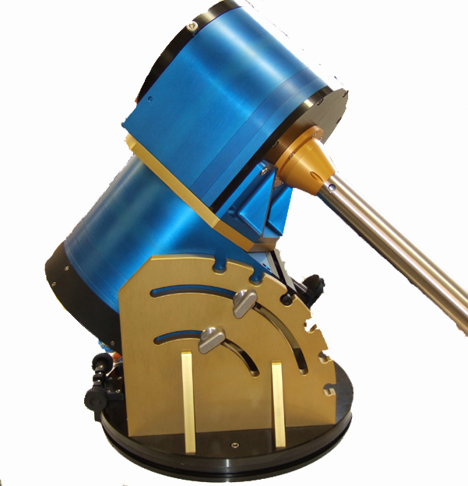

“NTM” is a trademark of ASTELCO Systems GmbH

“ASTELCO” is a registered trademark of ASTELCO Systems GmbH

© 2007. All rights reserved.
Contents

Introduction 4
Safety 4
1 Feature overview 5
2 General operating conditions 6
3 Installation 7
3.1 Control computer 7
3.2 NTM 7
3.3 Connection of the cable set 8
4 Instrument orientation and balancing 9
5 Factory Reset 11
6 Adjustment to the celestial pole 12
7 Pointing model 14
8 Creating a model 15
9 Refining a model 16
10 Network interface 17
Appendix 18
A Part list 18
B Control computer 19
C Cable set 21
D Abbreviations 24
Index 25

Introduction

This document is aimed to help you with the installation of the NTM. Please take yourself some time and read it carefully before you start with the installation process.

Safety

Please read the safety and precaution instructions carefully before you connect the NTM or power it. All safety critical issues will be marked with the following icons:

Icon | Description
 | Danger of electric shock. Endangers the user’s life!
 | Possible damage to the device is possible. May also endanger the user.
 | Possible damage to the device by ESD (electro-static discharge). Take precautions for proper grounding.

- Never use the NTM when you don’t have direct view to it.
- By operating the NTM, it will move. Take care that you stay in safe distance from all moving parts to avoid injuries.
- The motor cables carry high voltages. Never touch either end of it.
- Before plugging or unplugging the cables, the NTM controller must be disconnected from the power lines. Wait at least 3 minutes to ensure all internal capacitors are discharged.
- Before plugging or unplugging the cables, proper grounding must be ensured to avoid damage to the hardware by ESD.

1 Feature overview

The NTM is designed to operate with a wide range of user instruments providing both positioning speed and below arc-second precise tracking. The following table gives a list of edited features at a glance:

Feature | Comment
Speed | up to 100°/s, 100°/s²
Pointing | Built-in model for precise pointing and tracking
Pointing accuracy | < 5’ without pointing model, < 15” with pointing model
Tracking accuracy | Drift < 2’/h without pointing model, < 5”/h with model
Safety | Pressure brakes that stop any movement within seconds if any error occurs
Emergency off | Emergency off button at the control computer.
Network interface | Fully TCI2 compliant TPL2 network interface (optional)

2 General operating conditions

The NTM and its control computer are designed for clean and non-aggressive environments, with humidity between 15% and 85%, at heights <2000m (6562 ft) above sea level, and temperatures between +15°C (59F) and +40°C (104F). The power supply for the control computer should comply with EN 50178 and UL 840 standards. This table gives the maximum power used

Voltage | Current | Power consumption | Notes
220-240V | max. 7A | max. 1300W | Standard configuration (Europe)
110-125V | max. 15A | max. 1300W | On request, for export only (USA)

The next table gives the typical power consumption with different operations:

Power consumption | Operation
5W | Control computer turned off
65W | Control computer running, NTM turned off
85W | Computer and NTM turned on
135W | Pressure pump running to open brakes
90 … 400W | Slewing
90 … 120W | Tracking

3 Installation

Before installing the NTM, please make sure that you have all parts (see part list A). We suggest that you install it in the following order:

- Pass the cable set between the place of the mount and a protected place, where the control computer will be installed.
The cable must not be bent too tight to avoid damage. The minimum radius must be at least 10 cm.
- Install the control computer to its place.
- Install the NTM
- The cable set to the NTM.
- Connect the cable set to the control computer. The control computer must not be powered at this time!

3.1 Control computer

The control computer must be installed with some distance to adjacent walls, to ensure proper work of the cooling fans. To the front there should be at least 10 cm, to the back at least 25 cm distance.

Now connect the GPS receiver to the control computer and put it in a place where it has a good and free view to the sky.

Only connect it to the power if the NTM is installed and the cable set connected.

NTM

Put the NTM on your socket or pillar or tripod which should have been leveled before, so that the base plate of the NTM will also be leveled. The orientation should be as follows

Hemisphere | Orientation
Northern | Azimuth adjustment screw to the south
Southern | Azimuth adjustment screw to the north

The elevation must be set to your observing latitude. The notch spacing is 15°, starting at xxx.

Fix the counter weight bar with no weights attached.

Connection of the cable set
Please make sure that the control computer was at least 5 minutes disconnected from the power before you start to plug or unplug the cable set. Do not touch any of the pins of the connectors, since ESD can lead to damage of sensitive parts (e.g. the position encoders).
Always connect the NTM first, then the control computer. All cables are color coded and/or pin-coded. Wrong connection is impossible.

Instrument orientation and balancing

The instrument is attached to the instrument connector on top of the mount, shown in the image below.
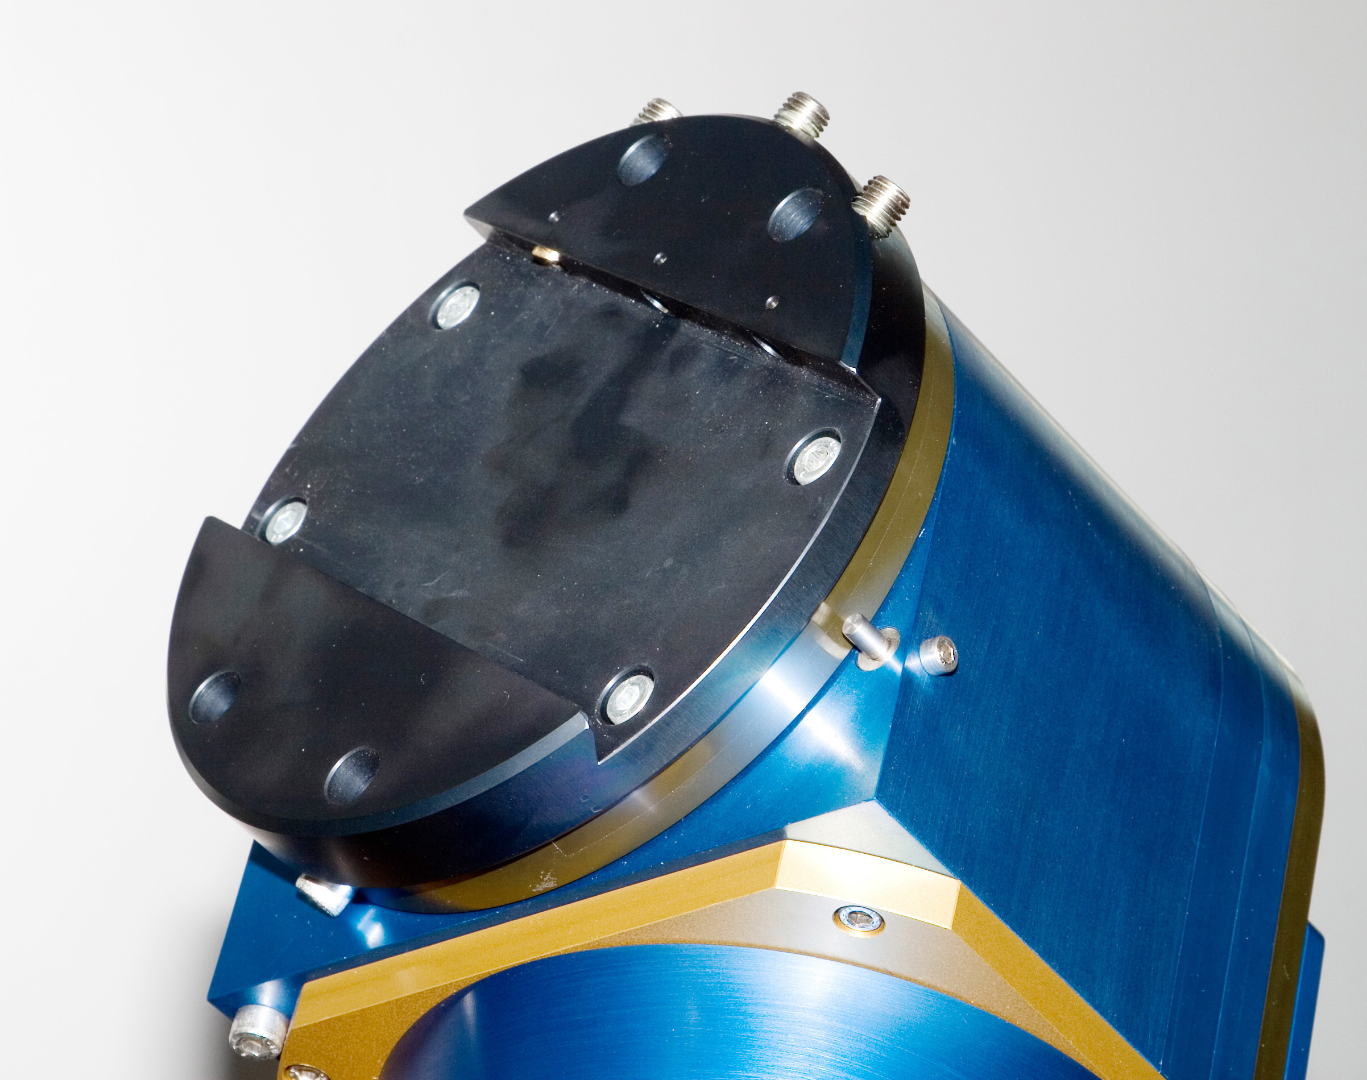
Before you mount your instrument, power the control computer and switch it on and release the brakes by turning the brake release key or pressing the brake release button at the back of the NTM.

Since the mount is not yet balanced, it will move in a position where the counter weight bar will point to the ground. Anticipate that movement (of the RA axis) to avoid injuries!

Turn the DEC axis to a position such that the bolt on the axis for the mechanical end stop is opposite to the end stop bolt on the case.

Fix the brakes again by switching the key switch back or by releasing the button. The System is now safe again and cannot move and you can now start mounting your instrument. The instrument must be oriented as follows:

Hemisphere | Orientation
Northern | Instrument points north
Southern | Instrument points south

To balance the system now, you need to do the following steps:

- Release the brakes while holding your instrument
- Estimate the appropriate counter weight by making small movements,
- Fix the brakes, attach the weight to the bar
- Repeat from step 1 until the system is balanced and will stay in any position with open brakes.

Now the orientation of the instrument can be checked: Turn the telescope on, and position both axes HA and DEC to 90°. The instrument must now aim directly north/south (see above) and the counter weight bar shows perpendicular to the ground.

Factory Reset

In case that the NTM is not working anymore as desired and you cannot figure out just why, there is the possibility to do a factory reset, which will re-initialize the computer to the state as delivered. All settings, pointing models etc. will be lost.

For a factory reset do the following steps:

- Press the reset button of the control computer for at least 15 seconds.
- The red led will start flashing. Do not switch it off or disconnect from power. The factory defaults are being restored.
- The led will turn red for 5 seconds to indicate the end of the process, the factory defaults have been restored.

6 Adjustment to the celestial pole

There are many methods adjusting the pole, e.g. classical ’Scheinern’ or a web cam based method (WCS, see http://wcs.ruthner.at/). For the NTM we suggest a method that is not only fast but also uses the built-in pointing model yielding a perfect adjusted pole together with the determination of a pointing model that will correct remaining mount errors.

Step 1: Create a pointing model with 7 stars (see chapter 7): point to 7 different stars, center them with an eye piece and save the centering offsets.

Step 2: Calculate the pointing model. Now point to any star in the south (northern hemisphere) or north (southern hemisphere) that is within ±1h of the meridian and has declination with sinΦ = tan|δ|, center it. The following table lists declinations for some given latitudes:

Latitude Φ | Declination δ
55 | ± 39°
45 | ± 35°
35 | ± 29°
25 | ± 23°

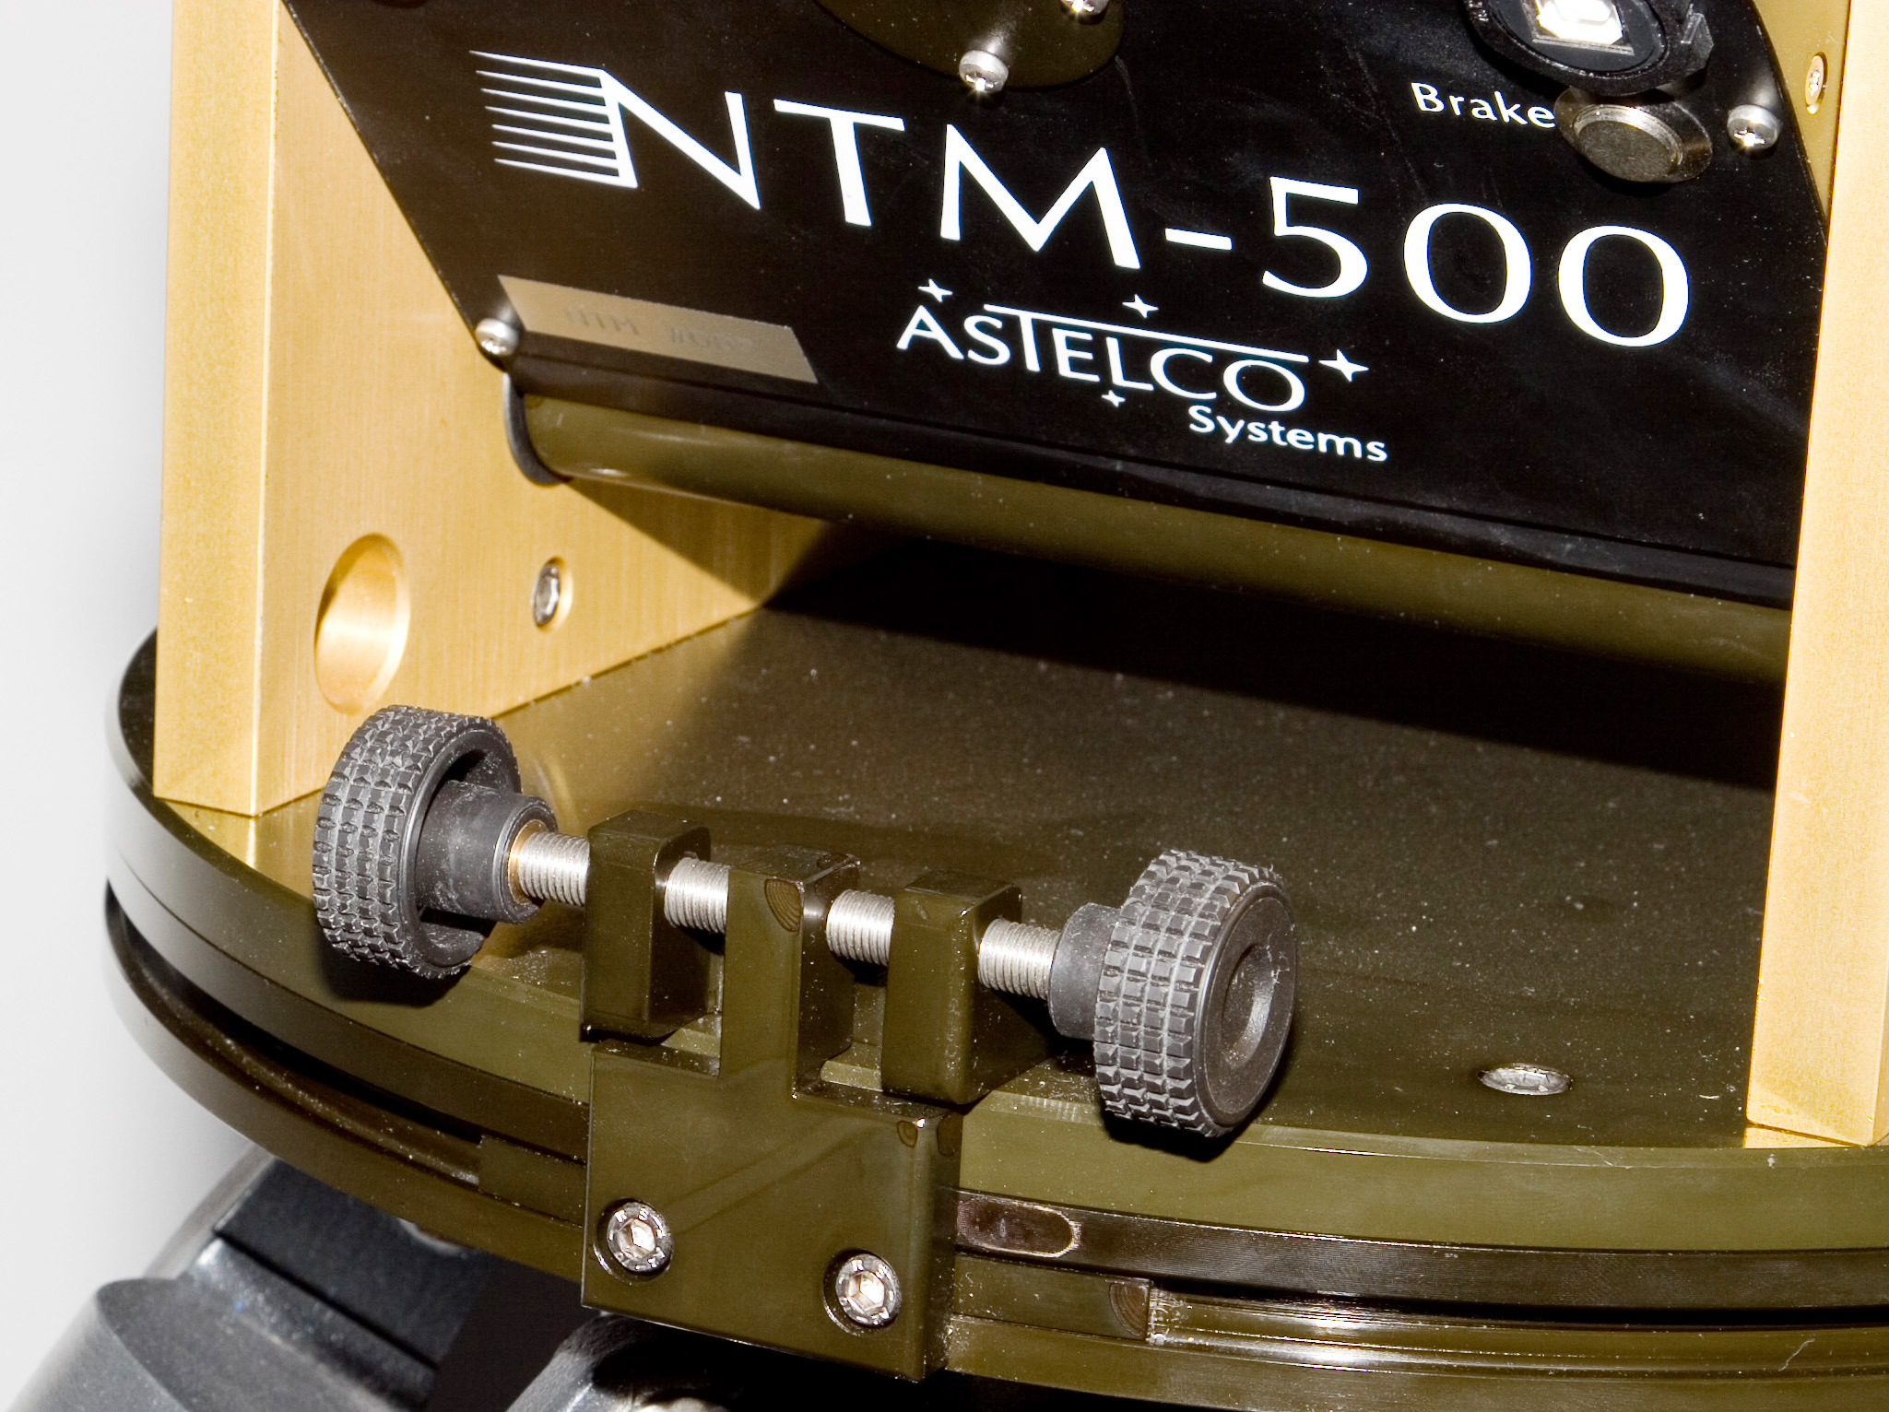
Loosen the azimuth base plate fixation screws, shown in the image on the left.

Now set the MA to 0.0. Use the azimuth adjustment screw to re-center the star. If the star is not anymore in the field of view after setting MA to 0.0 you can instead decrease the MA value in small steps, re-centering the star every time you change the value.

The following table gives the direction of the azimuthal rotation (if seen from above) needed:

MA | Rotation
> 0 | Clockwise (towards west)
< 0 | Counter-clockwise (towards east)

Step 3: Tighten the azimuth fixation screws and loosen the elevation fixation screws.
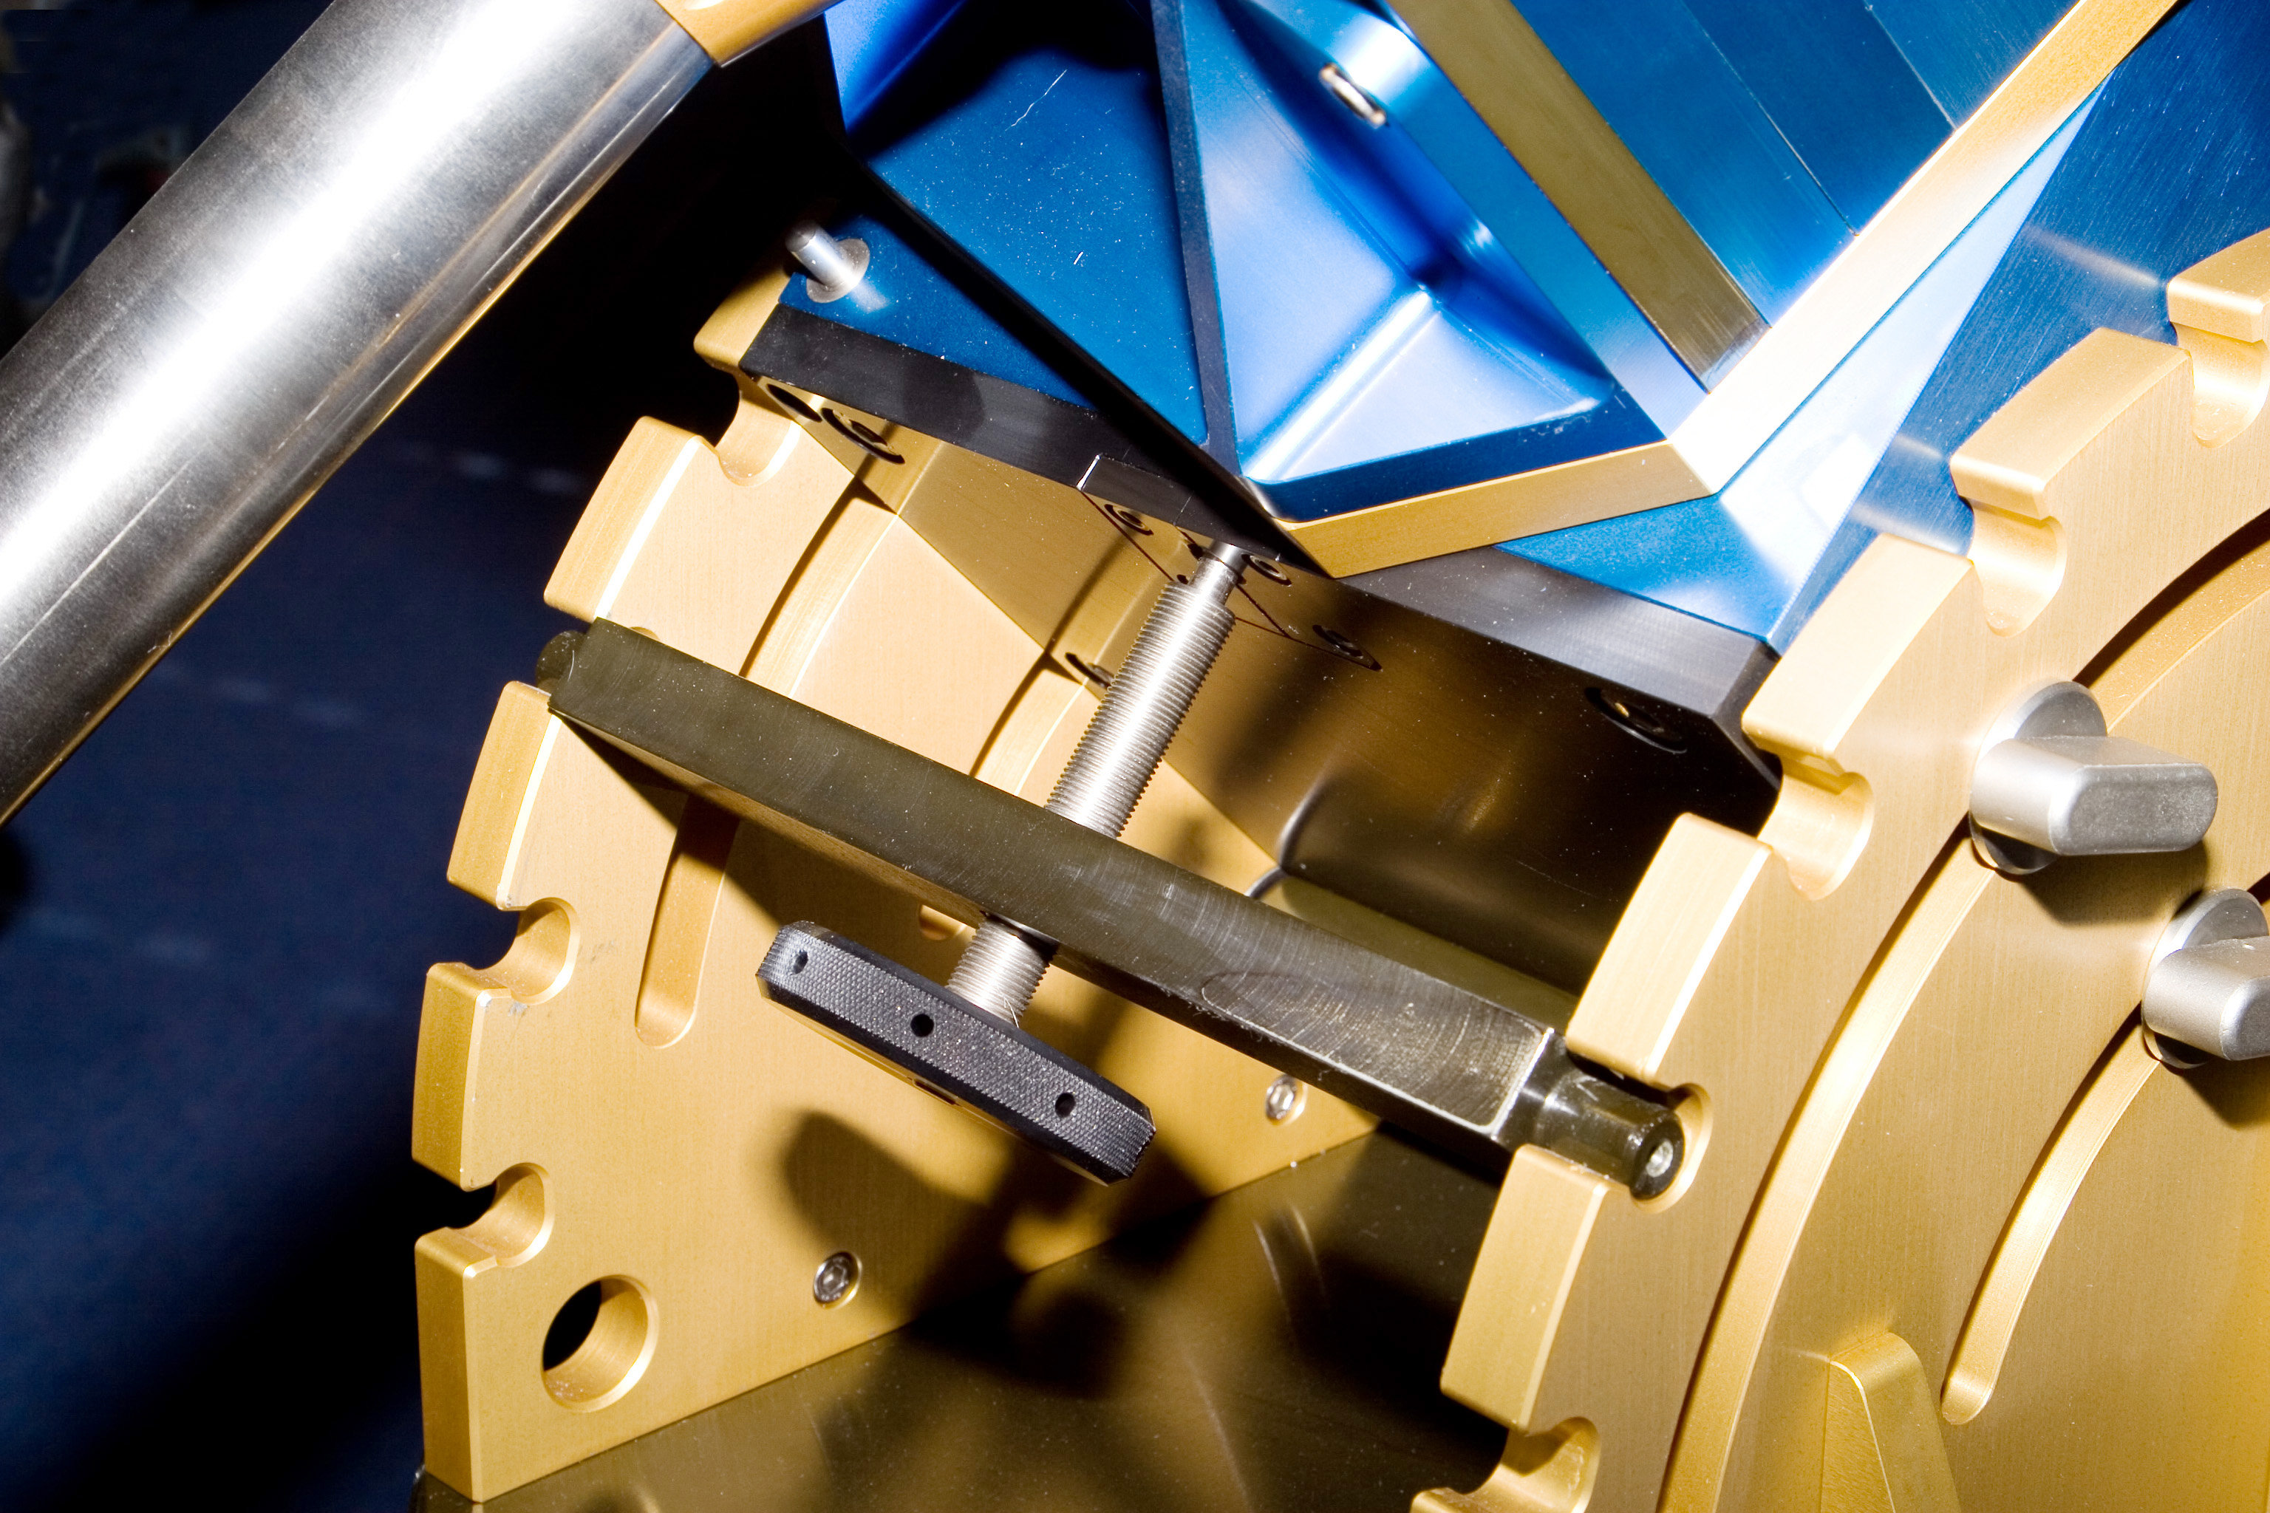
Use this star or any other star that is within ±1h of the meridian and set ME to 0.0. Use the elevation adjustment screw to re-center the star (shown on the image on the left). Again, you can change the value step by step to 0.0 if your FOV is not large enough.

The following table gives the direction of the elevation adjustment:

ME | Direction
> 0 | down (towards horizon)
< 0 | Up (towards zenith)

Step 4: Tighten the elevation and create a new pointing model with at least 7 stars. MA and ME should now be close to 0.0. Repeat from step 2, until you are satisfied with the remaining pole error.

7 Pointing model

The control software of the NTM provides a built-in pointing model which allows tracking of an object for several hours without guiding with a maximum drift of < 5”/h. The model consists of 7 terms that are computed by measuring the offsets needed to center at least 7 different stars. These 7 stars should be distributed over the sky for best results. The following terms will be used by the model:

Term | Description
HOFF | Absolute hour angle encoder offset
DOFF | Absolute declination encoder offset
NPHD | Hour angle axis not perpendicular to declination axis.
ME | Polar axis misalignment in elevation (counted towards zenith)  > 0: elevation must be decreased  < 0: elevation must be increased.
MA | Polar axis misalignment in azimuth (counted counter-clockwise, towards east).  When looking from above onto the base plate, MA  > 0: base plate must be rotated clockwise  < 0: base plate must be rotated counter-clockwise.
CH | Collimation axis not perpendicular to hour angle.
FLEX | Tube flexure term.

The next two equations are used to calculate the corrections for hour angle and
declination axis:
$$\begin{aligned}d_{H}=c_{\text{NPHD}}⋅\text{tan}(D) \\ −c_{\text{CH}}⋅\text{sec}(D)+c_{\text{ME}}⋅\text{sin}(H)⋅\text{tan}(D) \\ −c_{\text{MA}}⋅\text{cos}(H)⋅\text{tan}(D) \\ −c_{\text{FLEX}}⋅\text{cos}(φ)⋅\text{sin}(H)⋅\text{sec}(D) \\ +c_{\text{HOFF}}\end{aligned}$$
$$\begin{aligned}d_{D}=c_{\text{ME}}⋅\text{cos}(H) \\ +c_{\text{MA}}⋅\text{sin}(H) \\ +c_{\text{FLEX}}⋅\left(\text{cos}(φ)⋅\text{cos}(H)⋅\text{sin}(D)−\text{sin}(φ)⋅\text{cos}(D)\right) \\ +c_{\text{DOFF}}\end{aligned}$$

Where Φ is the telescope’s latitude, H and D the hour angle and declination. The terms and used formula are compatible with TPoint.

8 Creating a model

The principle idea behind the pointing model is to extract from a table of a few measurements values for the 7 terms described above. These values are then saved and will be used for future pointing/tracking operations. The following steps are needed to create an initial pointing model:

Step 1: Select an eye piece with a FOV ≈ 5’. Do never change the eye piece during the creation, since it will spoil the results.

Step 2: Choose any bright (< 2.0 magnitude) star and point the NTM to it.

Step 3: Center the star in the FOV by setting offsets in HA and DEC.

Step 4: Add this measurement to the calculation list. Repeat from Step 2 until you have at least 7 measurements.

Step 5: Start the calculation. This may take some seconds and will then erase the offsets you have set since these are now calculated internally by the pointing model.

9 Refining a model

Refining a model works basically the same as creating a model. The only difference is that when refining a model, you have already some previously created model working and thus the centering works will happen much faster. You should also use a FOV with only ≈ 1’ possibly using a Barlow lens to be able to center the stars more precisely, resulting in a much more precise model. You should also make at least 20 measurements to distribute the remaining errors evenly across the sky. Too few measurements will result in good accuracy in one part of the sky and worse in another part. The more measurements you make the more equal the accuracy will be.

10 Network interface

The NTM features optionally a fully TCI2 compliant TPL2 based network interface. All functionality from switching the system on to pointing model creation is accessible via network. Please read the TCI2 documentation for further details.

Appendix

A Part list

Part | Description
NTM | Mount
Control computer | 19” Control computer (incl. power cable and GPS receiver)
Cable set | Cable set to connect the NTM with the control computer WARNING: please read safety instructions before connecting!
CD-ROM | Driver for TheSky (Windows), documentation.

B Control computer

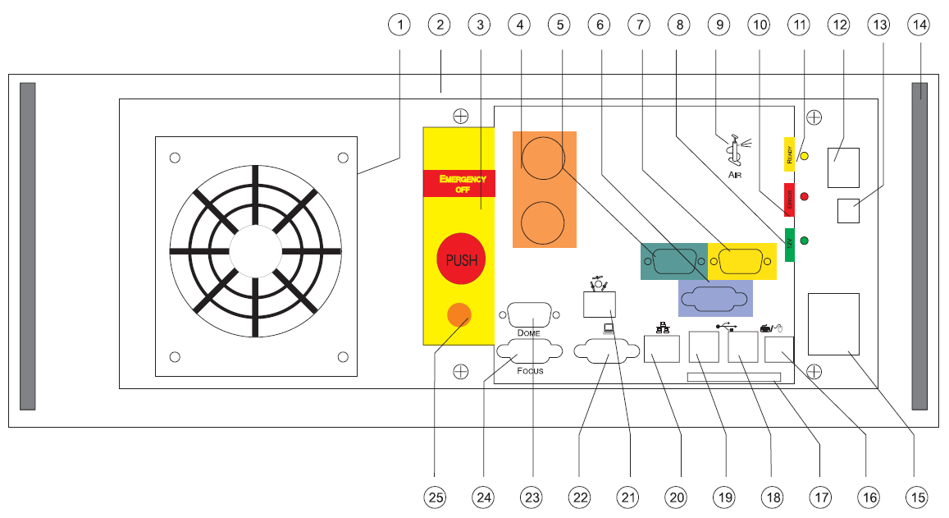

Number | Description
1 | Front fan
2 | 19” case, fits in 19” racks
3 | Emergency off
4 | Motor 1+2 Power
5 | Encoder input Motor 1
6 | Limit switch input
7 | Encoder input Motor 2
8 | LED 12V OK (green)
9 | Pressure
10 | LED Error (red)
11 | LED Motor power on (yellow)
12 | Fan alarm reset
13 | Control computer reset
14 | Handle
15 | Power on switch
16 | Keyboard (optional)
17 | Memory card
18, 19 | USB (optional)
20 | Ethernet connector
21 | GPS receiver connector
22 | Monitor (optional)
23 | Dome control (optional)
24 | Focus control (optional)
25 | Pressure exhaust

C Cable set

The cable set is made of 7 cables that are both encoded by color and by different plugs/pins. Wrong connection is therefor impossible. Suffix ’-f’ means female, ’-m’ male.

Color | NTM | Computer | Function
orange | PWR-f | PWR-f | Power for Motor 1 + 2 (pincoded) WARNING: high voltage!
green | DSUB15-f | DSUB9-f | Position encoder for motor 1
yellow | DSUB15-f | DSUB9-m | Position encoder for motor 2
blue | HDSUB15-f | HDSUB15-m | Control lines (limit switches, brake release keys, emergency off)
grey | DIN3p-f | DIN3p-f | 12V (max. 3 A) for user
black | Pressure | Pressure | Pressure for brakes

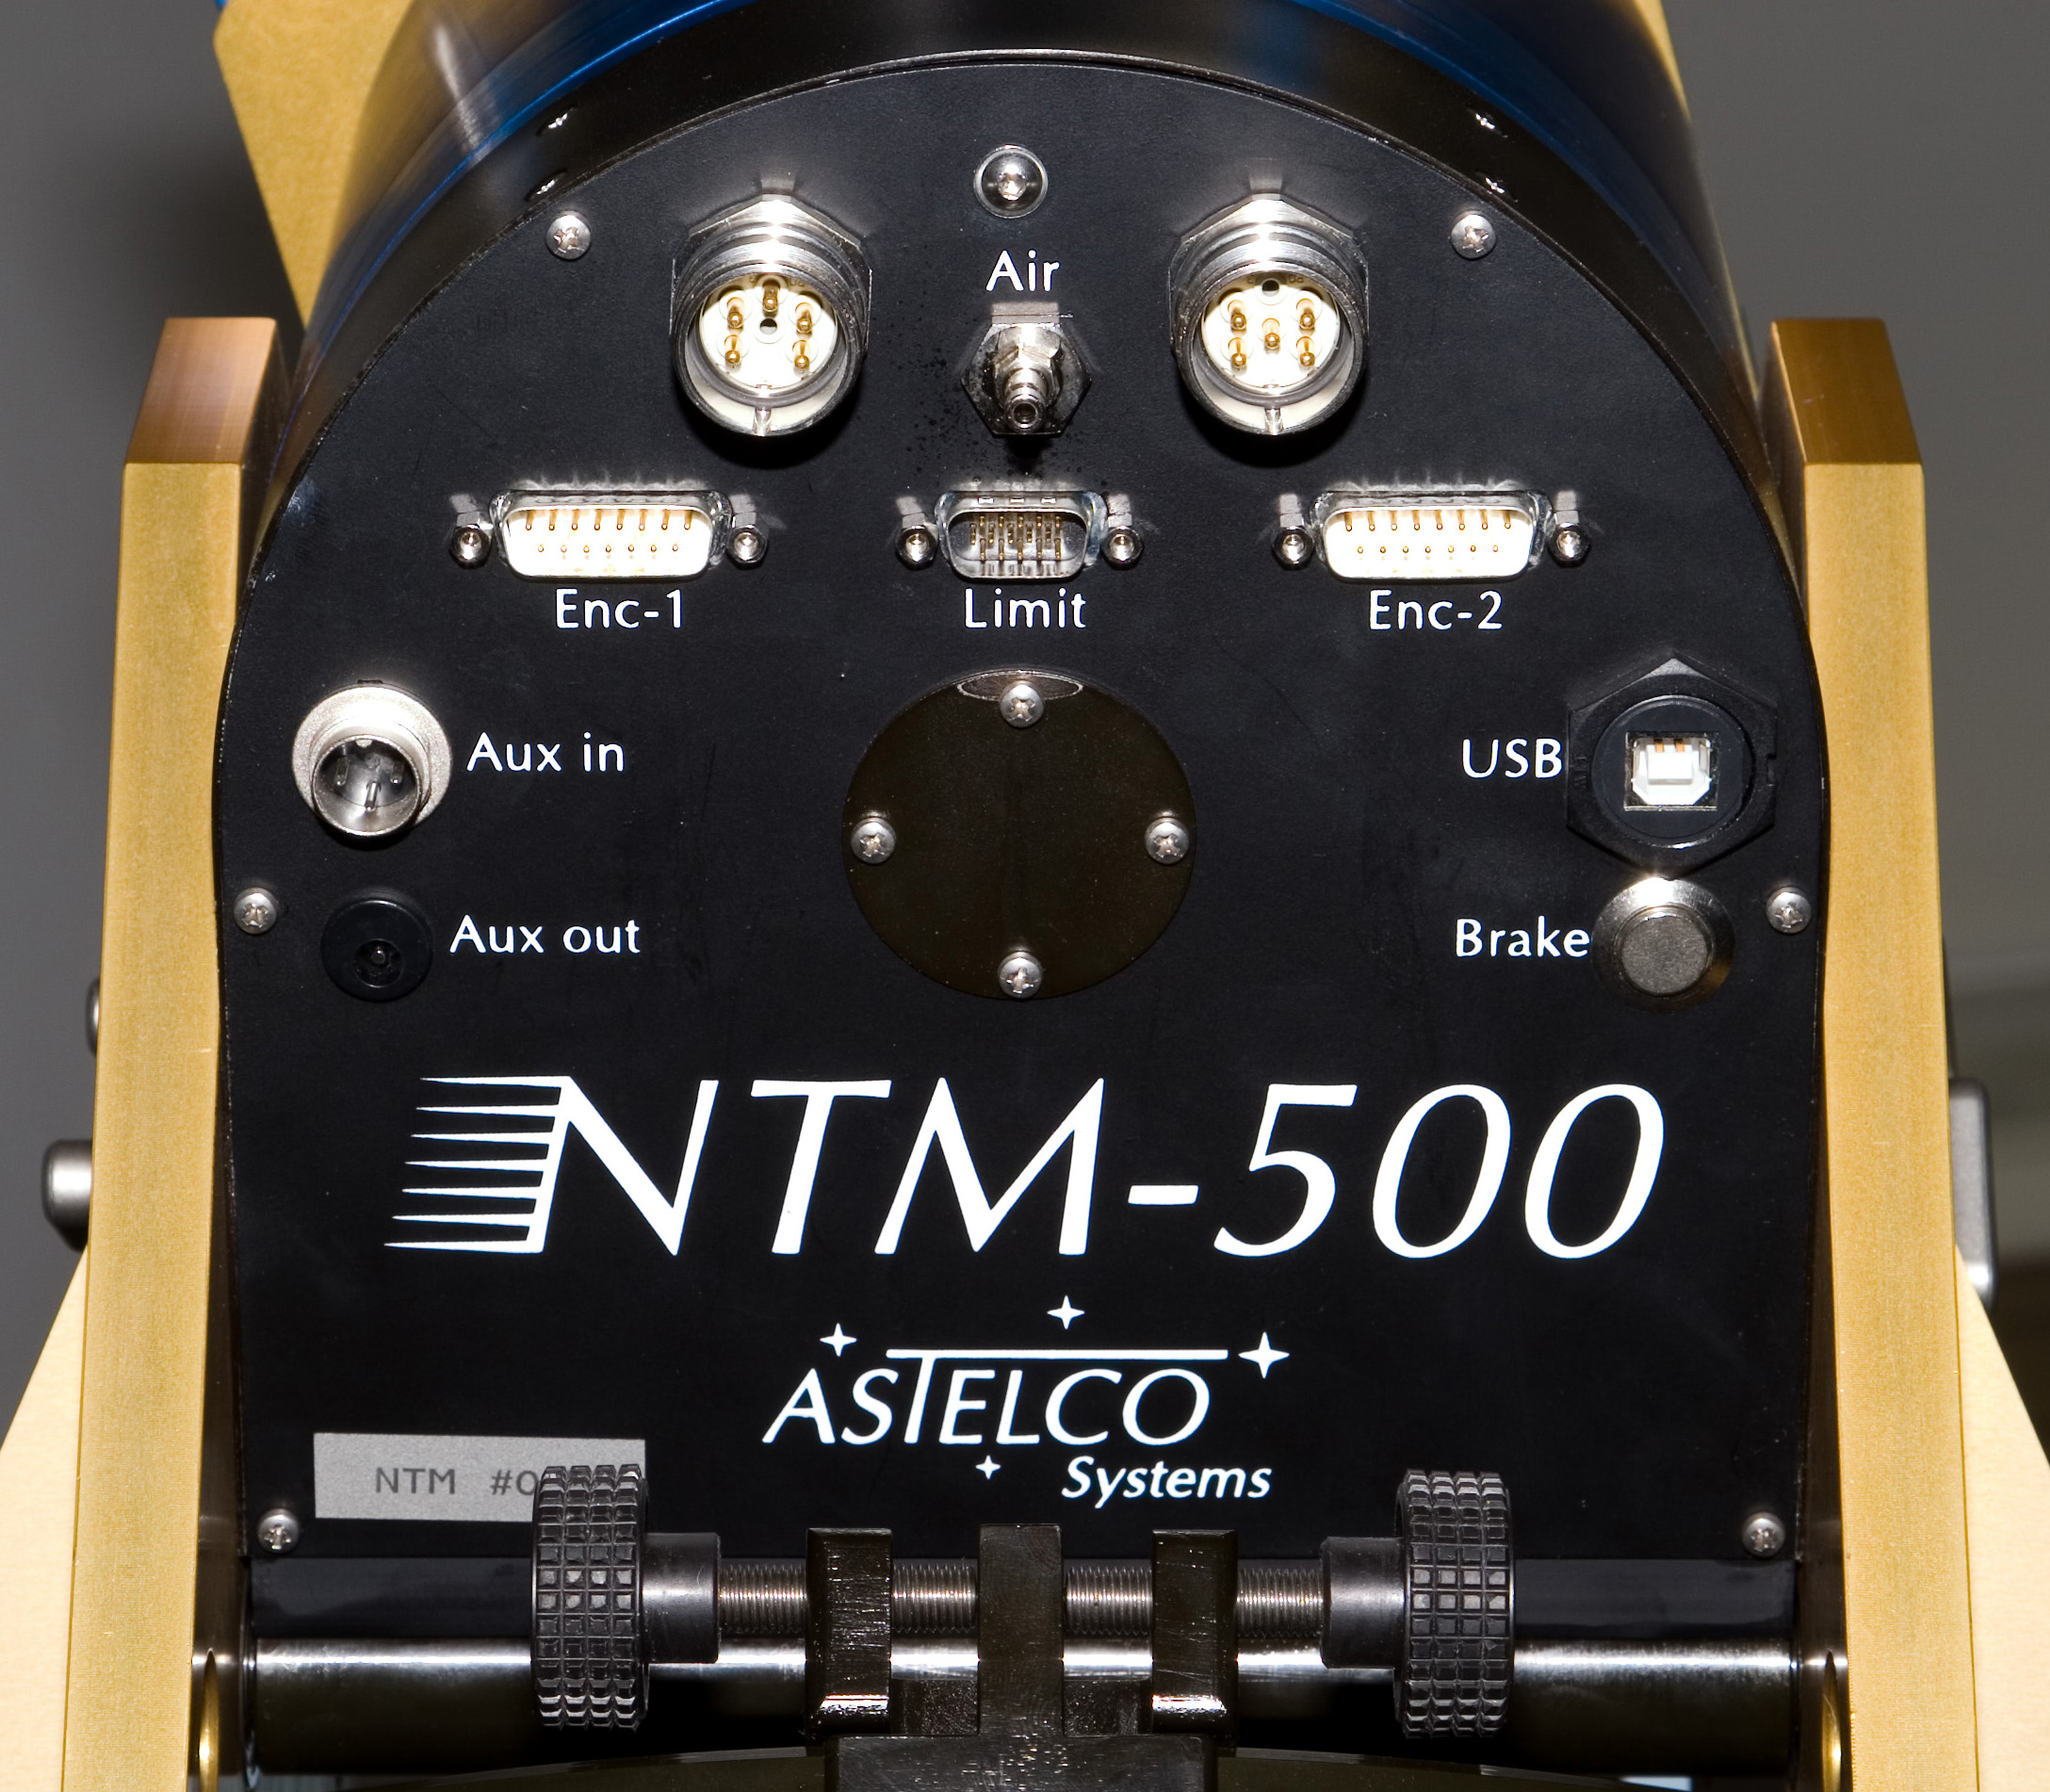
The image below shows the connector panel of the NTM, where the cables are connected to.

Layout of the motor connectors

Connector with 6 poles female.

WARNING: This cable carries high voltage! Before plugging or unplugging disconnect the whole system from the power and wait at least 3 minutes.

Pin | Name | Description
1 | PH1 | Motor phase 1
2 | PH2 | Motor phase 1
3 | - | -
4 | PH3 | Motor phase 1
5 | GND | Ground
6 | - | -

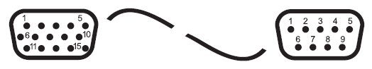
Layout of position encoder connectors

DSUB15 connector (NTM) to DSUB9 (computer), S-FTP cable.

WARNING: Both encoders and motor controllers are very sensitive to ESD. Before plugging or unplugging it is important to be grounded properly. Do not touch the pins of the connectors.

Pin NTM | Pin Computer | Wire | Name | Description
1 | - | - | - | -
2 | - | - | - | -
3 | - | - | - | -
4 | 3 | yellow/white | $U_{0^{−}}$, Ref - | Index (-)
5 | 1 | brown | $U_{2^{−}}$, Cos - | Cosine-Signal (-)
6 | 5 | green/white | $U_{1^{−}}$, Sin - | Sine-Signal (-)
7, 8 | 7 | blue | $V_{C}$, +5V | Power supply
9 | 8 | blue/white | 0V, GND | Ground
10 | - | - | - | -
11 | - | - | - | -
12 | 4 | yellow | $U_{0+}$, Ref + | Index (+)
13 | 2 | brown/white | $U_{2^{+}}$, Cos + | Cosine-Signal (+)
14 | 6 | green | $U_{1+}$, Sin + | Sine-Signal (+)
15 | - | - | - | -
Layout of control connectors
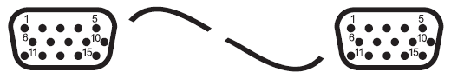

HDSUB15 connector (NTM) to HDSUB15 (computer), FTP cable.

Pin NTM | Pin computer | Name | Description
1 | 1 | LIM₁₁ | Motor 1, limit switch 1
2 | 2 | LIM₁₂ | Motor 1, limit switch 2
3 | 3 | GND | Ground
4 | 4 | LIM₂₁ | Motor 2, limit switch 1
5 | 5 | LIM₂₂ | Motor 2, limit switch 2
6 | 6 | NOT | Emergency off (optional)
7 | 7 | BRK | Brake release
8 | 8 | V_{CC} | Supply (+24V)
- | 9 | GND | Ground
- | 10 | TEMP | Temperature sensor
- | 11 | V_{CC} | +24V
- | 12 | V_{CC} | +24V
- | 13 | V_{CC} | +24V
- | 14 | - | Ground
- | 15 | TGND | Ground for sensor

Layout of the 12V user supply

DIN connector, 3 poles female
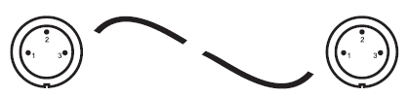

Pin NTM | Pin Computer | Wire | Name | Description
1 | 1 | black | +12V | 12V (max 3A)
2 | 2 | - | -
3 | 3 | black | GND | Ground

D Abbreviations

Abbreviation | Description
NTM | ASTELCO New Technology Mount

Index

Cable set, 21
Layout, 21
Control computer
Drawing, 19

Factory Reset, 11
Features, 5

Installation, 7
Balencing, 9
Cable set, 8
Control computer, 7
Instrument, 9
NTM, 7

Operating conditions, 6
Height, 6
Humidity, 6
Power, 6
Temperature, 6

Part list, 18
Pole adjustment, 12

Safety, 4

Depending on the weight of the attached instruments
Actually it is not the exactly the RA axis but the HA (hour angle) axis. However we will use both names as synonyms unless it is important to discriminate, e.g. between a RA coordinate and a HA coordinate.

